CSS ISLAMIC STUDIES · T9KB
بِسۡمِ ٱللَّهِ ٱلرَّحۡمَٰنِ ٱلرَّحِيمِ
Topic IX — The Islamic Code of Life — Sources of Law and the Islamic Systems
The Knowledge Base · Islam as a complete code of life and the Maqasid; the sources of law — Quran, Sunnah, Ijma, Qiyas and Ijtihad; and the social, political, economic, judicial and administrative systems
Twelve chapters built from syllabus Head VII and the line 'Sources of Islamic Law', and from the eight questions set on this topic between 2015 and 2026, with the contemporary debates, the examiner's record, five likely questions, a numbered one-liner bank and section-by-section revision notes. Every point carries its evidence — the Quran first, then the Hadith, then the Companions, the jurists, the law and the data — inside the point itself.
Edition of September 2026 · covers the papers of 2015–2026 · written for CSS 2027 and after
Contents
HOW TO BUILD THE CONTENTS
The Contents below is left empty on purpose. In Microsoft Word, right-click anywhere on the grey line below and choose Update Field → Update entire table → OK. The full table of contents with page numbers will appear.
On a Mac: right-click (or Control-click) the line → Update Field. If you edit the notes later, repeat this step to refresh the page numbers. You can also press Ctrl + A then F9 (Windows) to update every field in the document at once.

How to Use This Document 9
What this topic covers 9
How this document is built 10
Part Zero — The ABC Before the Chapters 12
0.1 The words of this topic 12
Chapter 1 · Islam as a Complete Code of Life: The Salient Features of the Islamic System 13
1.1 Islam — a Din, not only a religion 13
1.2 The salient features of the Islamic system 14
(1) Divine source — Tawhid at the centre 14
(2) Comprehensiveness 14
(3) Balance (wasatiyyah) 14
(4) Justice 15
(5) Ease and removal of hardship 15
(6) Universality 15
(7) Permanence and flexibility (thabat and murunah) 15
(8) Moral foundation 16
(9) Rights with duties 16
(10) Human welfare — the Maqasid 16
(11) Practicality 16
1.3 Maqasid al-Shari'ah — the objectives of the law 16
(1) The five essentials 17
(2) The three levels (al-Shatibi, Al-Muwafaqat) 17
(3) Why the Maqasid matter today 17
1.4 How the systems work together 17
Chapter 2 · The Sources of Islamic Law and the Quran 19
2.1 The sources — an overview 19
2.2 The Quran as the first source 20
(1) Definition 20
(2) Its authority 20
(3) The legal verses 21
(4) The features of Quranic legislation 21
(5) Certain and probable meaning 21
(6) Abrogation (naskh) 21
2.3 How the sources work together 22
Chapter 3 · The Sunnah: Its Importance in Interpretation and Legislation 23
3.1 Meaning 23
3.2 The authority of the Sunnah — from the Quran 23
3.3 The authority of the Sunnah — from the Sunnah itself 24
3.4 The importance of the Sunnah in interpretation (tafsir) 25
(1) It explains the brief (bayan al-mujmal) 25
(2) It specifies the general (takhsis al-'amm) 25
(3) It restricts the absolute (taqyid al-mutlaq) 25
(4) It explains words and concepts 25
(5) It confirms (ta'kid) 26
3.5 The importance of the Sunnah in legislation (tashri') 26
3.6 The Sunnah as the living model 26
3.7 The preservation of the Sunnah 26
3.7a The kinds of hadith — which Sunnah is a proof? 26
3.8 The Sunnah in Pakistan's law 27
3.9 The modern denial of hadith — a short answer 27
Chapter 4 · Ijma: Definition, Kinds, Procedure — and Parliament 28
4.1 Definition 28
The elements of the definition 28
4.2 The authority of Ijma — the Quran 28
4.3 The authority of Ijma — the Sunnah 29
4.4 The kinds of Ijma 30
(1) By the way it is expressed 30
(2) By its period and people 30
(3) By its certainty 30
4.5 Examples of Ijma 30
4.6 Its importance 31
4.7 The procedure of Ijma 31
(1) In the classical age 31
(2) In the modern age — collective Ijtihad 31
4.8 Can a parliament's legislation be a valid consensus? (2023) 31
(1) The case for — Iqbal's view 31
(2) The case against — why it is not classical Ijma 32
(3) A balanced answer 32
(4) Pakistani examples 32
4.9 Ijma and difference of opinion (ikhtilaf) 32
Chapter 5 · Qiyas and the Secondary Sources 34
5.1 Qiyas — definition 34
5.2 The four pillars (arkan) 34
5.3 The authority of Qiyas 34
5.4 The conditions of the 'illah 35
5.5 Examples 35
5.5a The importance of Qiyas 35
5.6 The secondary sources 36
(1) Istihsan (اِسْتِحْسَان) — juristic preference (Hanafi) 36
(2) Maslahah mursalah (مَصْلَحَة مُرْسَلَة) — public interest (Maliki) 36
(3) 'Urf (عُرْف) — custom 36
(4) Istishab (اِسْتِصْحَاب) — presumption of continuity 36
(5) Sadd al-dhara'i' (سَدُّ الذَّرَائِع) — blocking the means 36
(6) Qawl al-Sahabi — the opinion of a Companion 36
(7) Shar' man qablana — the laws of earlier prophets 36
Chapter 6 · Ijtihad: Concept, Conditions, Principles and Contemporary Importance 38
6.1 The concept of Ijtihad 38
6.2 The authority of Ijtihad 38
The Prophet's ﷺ approval of the Companions' Ijtihad 39
6.3 The Ijtihad of the Rightly-Guided Caliphs 39
6.4 The conditions of a mujtahid 39
6.5 The kinds of Ijtihad 40
(1) By the level of the mujtahid 40
(2) By the number of people 40
(3) By its method 40
(4) Full and partial 40
6.6 The principles of Ijtihad (2022) 40
6.7 Was the 'gate of Ijtihad' closed? 41
6.8 The contemporary importance of Ijtihad 41
(1) New questions that the classical books did not face 41
(2) Keeping the Shari'ah alive and relevant 41
(3) Answering both extremes 41
(4) Islamising the law in Pakistan 42
(5) Unity of the Ummah 42
Chapter 7 · The Social System of Islam 43
7.1 The foundations 43
(1) Tawhid and the unity of mankind 43
(2) Equality and dignity 43
(3) Brotherhood 44
7.2 The salient features of the social system 44
(1) The family — the first unit of society 44
(2) Rights of relatives, neighbours and the weak 45
(3) The status of women 45
(4) Social justice and welfare 45
(5) Enjoining good and forbidding evil 45
(6) Modesty and purity 46
(7) Ban on social evils 46
(8) Knowledge and education 46
(9) Tolerance and rights of non-Muslims 46
(10) Etiquette of social life 46
(11) Institutions of social life 46
(12) Social security for the weak 46
7.2a The Islamic and the Western social systems compared 47
7.3 Relevance to modern society 47
Chapter 8 · The Political System of Islam 48
8.1 The salient features 48
8.1a The aims of the Islamic state 48
8.1b The rights of citizens 49
8.1c The duties of citizens 49
8.2 In Pakistan 49
Chapter 9 · The Economic System of Islam 50
9.1 The nature of Islamic economics 50
9.2 The main principles of Islamic economics (2022) 50
(1) Allah is the owner; man is a trustee 51
(2) Right to private property, within limits 51
(3) Lawful and good earning (halal and tayyib) 51
(4) Prohibition of riba (interest) 52
(5) Prohibition of gambling (maysir) and excessive uncertainty (gharar) 53
(6) Prohibition of hoarding 53
(7) Zakat and spending 54
(8) Circulation of wealth 54
(9) Fair dealing in trade 54
(10) Moderation — neither miserliness nor waste 55
(11) Rights of labour 55
(12) Inheritance — wealth divided at every death 55
(13) Social security — the state's duty 56
(14) Contracts and documentation 56
9.3 The instruments of Islamic finance 56
9.4 How the principles solve contemporary challenges (2020, 2022) 56
9.4a The economic effects of Zakat 57
9.4b Pakistan's economic challenges and Islamic answers 57
9.5 Is the Islamic system 'the solution'? A balanced view (2020) 57
Chapter 10 · Concentration of Wealth and Riba 59
10.1 The problem today 59
10.2 The disadvantages of concentration of wealth 59
(1) Poverty amid plenty 59
(2) Class hatred and social unrest 59
(3) Economic slowdown 59
(4) Monopoly and exploitation 59
(5) Political capture 59
(6) Moral decay — the Qarun syndrome 59
(7) Weakness of the Ummah 60
10.3 The measures Islam introduced to prevent concentration 60
(1) Zakat — a yearly transfer 60
(2) The law of inheritance 61
(3) Prohibition of riba 61
(4) Prohibition of hoarding (kanz and ihtikar) 61
(5) Voluntary spending (infaq and sadaqah) 61
(6) Waqf — permanent charity 61
(7) Public ownership of essential resources 61
(8) Distribution of state revenue (fay') 62
(9) Unused land returns to use 62
(10) Expiations, vows and obligatory charities 62
(11) Ban on unjust gains 62
(12) Fair wages and the dignity of work 62
10.3a Modern examples of Islamic redistribution 62
10.4 Riba in Pakistan 63
Chapter 11 · The Judicial System of Islam 65
11.1 The place of justice in Islam 65
11.2 The salient features of the Islamic judicial system 66
(1) Independence of the judiciary 66
(2) Equality before the law 66
(3) Rules of evidence 67
(4) Hearing both sides 67
(5) Judgement on the apparent evidence 67
(6) The presumption of innocence 67
(7) Qualified, upright judges 68
(8) The judge's temperament 68
(9) No bribery, no gifts 68
(10) Free and speedy justice 68
(11) Review and appeal 68
(12) Justice to non-Muslims 69
11.2a The Prophet ﷺ as judge 69
11.2b Great judges of Islamic history 69
11.3 The courts and institutions 69
11.4 Punishments in brief 70
11.5 Lessons for Pakistan 70
Chapter 12 · The Administrative System of Islam 71
12.1 The salient features 71
12.2 The departments (diwans) of the early state 71
12.3 The Prophet's ﷺ and Umar's model 71
12.4 Lessons for Pakistan's administration 72
Part Two — Contemporary Challenges, Narratives and Hot Debates 73
13.1 The elimination of riba by 2028 — can it be done? 73
13.2 Islamic banking — the real thing or a new label? 73
13.3 Zakat — a system underused 73
13.4 Ijtihad on new questions 74
13.5 Taqlid and Ijtihad — a false fight 74
13.6 Parliament and Ijma in Pakistan 74
Part Three — The Examiner's Record and Five Likely Questions 75
14.1 Every question on this topic, 2015–2026 75
14.2 What the record teaches 75
14.3 Five likely questions 75
Part Four — The One-Liner Bank 76
One-liners · The code of life and the Maqasid 76
One-liners · The sources and the Quran 76
One-liners · The Sunnah 76
One-liners · Ijma 77
One-liners · Qiyas and the secondary sources 77
One-liners · Ijtihad 77
One-liners · The social, political, judicial and administrative systems 78
One-liners · The economic system and wealth 78
Part Five — Revision Notes · Topic 9 80
R9.0 The whole topic in one picture 80
R9.1 Chapter 1 · The code of life 80
R9.2 Chapter 2 · The sources and the Quran 80
R9.3 Chapter 3 · The Sunnah (2015) 80
R9.4 Chapter 4 · Ijma (2017, 2023) 81
R9.5 Chapter 5 · Qiyas and the secondary sources 81
R9.6 Chapter 6 · Ijtihad (2018, 2022) 82
R9.7 Chapter 7 · The social system (likely) 82
R9.8 Chapter 8 · The political system 83
R9.9 Chapter 9 · The economic system (2020, 2022) 83
R9.10 Chapter 10 · Concentration of wealth and riba (2025) 83
R9.11 Chapter 11 · The judicial system (likely) 84
R9.12 Chapter 12 · The administrative system 84
R9.13 Part Two · Today 84
R9.14 The figures to draw in the paper 85

How to Use This Document

What this topic covers
Topic 9 joins syllabus Head VII — the Islamic Code of Life with the line 'Sources of Islamic Law' from Head VI. Head VII covers the salient features of the Islamic system (social, political, economic, judicial, administrative) and the procedure of Ijma and Ijtihad. The examiner has set eight questions here since 2015, falling into two families:
- the sources of law — Sunnah 2015, Ijma 2017 and 2023, Ijtihad 2018 and 2022;
- the economic system — 2020, 2022 and 2025.
Syllabus line / past question | Where it is taught
Islam as a complete code of life; salient features; Maqasid al-Shari'ah | Chapter 1
The sources of law; the Quran | Chapter 2
The importance of the Sunnah in interpretation and legislation (2015) | Chapter 3
Ijma: definition, kinds, importance (2017); parliament and Ijma (2023) | Chapter 4
Qiyas and the secondary sources | Chapter 5
Ijtihad: concept, contemporary importance, principles (2018, 2022) | Chapter 6
The social system | Chapter 7
The political system | Chapter 8
The economic system (2020); principles of Islamic economics (2022) | Chapter 9
Concentration of wealth (2025); riba | Chapter 10
The judicial system | Chapter 11
The administrative system | Chapter 12

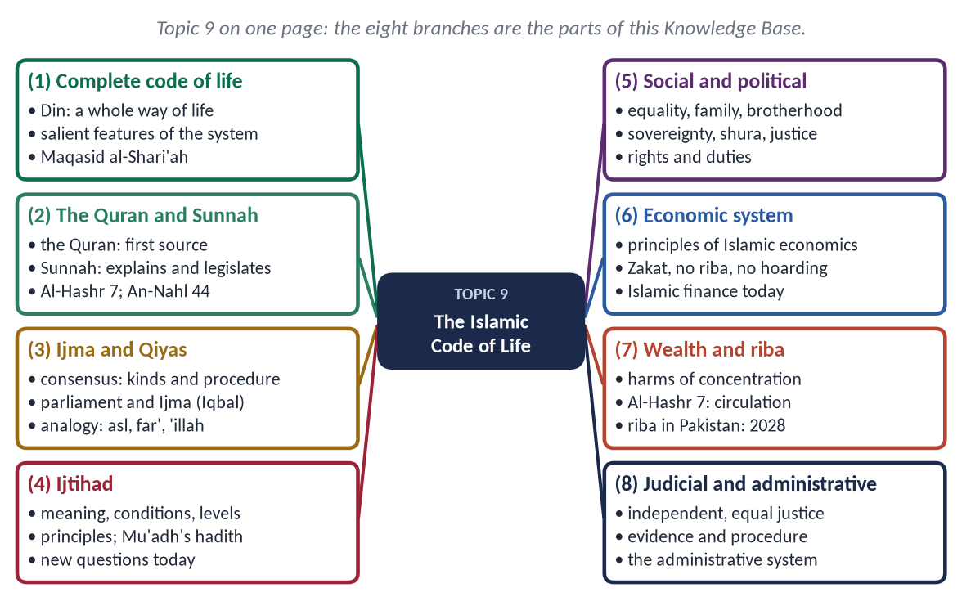
Figure 1 · Topic 9 on one page. The eight branches are the parts of this Knowledge Base.

How this document is built
1. Part Zero — the ABC: the words of the topic.
2. Part One — twelve chapters. In every point the evidence comes Quran → Hadith → Companions and jurists → scholars, law and data.
3. At-a-glance charts after long sections, giving the names only.
4. Part Two — contemporary challenges and hot debates.
5. Part Three — the examiner's record and five likely questions.
6. Part Four — the numbered one-liner bank.
7. Part Five — section-by-section revision notes.
EXAMINER'S EYE · THIS TOPIC IN THE PAPER
Usul questions (Sunnah, Ijma, Ijtihad) are marked on precision. The examiner looks for:
• the exact definition (literal and technical);
• the evidence from the Quran and Sunnah;
• the kinds and conditions;
• the examples;
• the modern application (CII, the Fiqh Academy, parliament).
Economics questions are marked on principles plus solutions: verses, then how they answer poverty, inequality, riba and debt, with Pakistani data.

TRAP · DEFINITIONS WITHOUT EXAMPLES
A definition of Ijma or Qiyas without one clear example scores little. Learn one example for every kind:
• Ijma: the compilation of the Quran;
• Qiyas: wine to drugs;
• Istihsan: istisna';
• Maslahah: Umar's Diwan;
• Ijtihad today: takaful and organ donation.

Part Zero — The ABC Before the Chapters

0.1 The words of this topic
Term | Arabic | Meaning in this topic
Din | دِين | A complete way of life — belief, worship, law, morals, society.
Shari'ah | شَرِيعَة | Literally 'the path to water'; the revealed law of Allah.
Fiqh | فِقْه | Literally 'understanding'; the jurists' knowledge of practical rulings derived from detailed evidence.
Usul al-Fiqh | أُصُولُ الْفِقْه | The principles of jurisprudence — the method of deriving law.
Maqasid al-Shari'ah | مَقَاصِدُ الشَّرِيعَة | The objectives of the Shari'ah.
Maslahah | مَصْلَحَة | Benefit, public interest.
Sunnah | سُنَّة | The way of the Prophet ﷺ: his sayings, actions and approvals.
Ijma' | إِجْمَاع | Consensus of the qualified jurists.
Qiyas | قِيَاس | Analogy.
'Illah | عِلَّة | The effective cause of a ruling.
Ijtihad | اِجْتِهَاد | The utmost effort of a qualified jurist to derive a ruling.
Mujtahid | مُجْتَهِد | One qualified to do Ijtihad.
Taqlid | تَقْلِيد | Following a qualified scholar or school.
Istihsan | اِسْتِحْسَان | Juristic preference (Hanafi).
Riba | رِبَا | Interest, usury — any fixed increase on a loan.
Gharar | غَرَر | Excessive uncertainty in a contract.
Maysir | مَيْسِر | Gambling.
Ihtikar | اِحْتِكَار | Hoarding goods to raise prices.
Qada' | قَضَاء | The judiciary; judging.

Chapter 1 · Islam as a Complete Code of Life: The Salient Features of the Islamic System

1.1 Islam — a Din, not only a religion
In the modern sense, 'religion' means private belief and worship. The Quran calls Islam a Din (دِين): a complete way of life, covering the individual, the family, society, the economy and the state.
✦ QURAN
﴿إِنَّ ٱلدِّينَ عِندَ ٱللَّهِ ٱلۡإِسۡلَٰمُۗ …﴾
“Indeed, the religion with Allah is Islam.” (Aal-e-Imran, Quran)
➜ 'Indeed, the Din with Allah is Islam.'

✦ QURAN
﴿يَـٰٓأَيُّهَا ٱلَّذِينَ ءَامَنُواْ ٱدۡخُلُواْ فِي ٱلسِّلۡمِ كَآفَّةٗ وَلَا تَتَّبِعُواْ خُطُوَٰتِ ٱلشَّيۡطَٰنِۚ إِنَّهُۥ لَكُمۡ عَدُوّٞ مُّبِينٞ﴾
“O you who have believed, enter into Islam completely [and perfectly] and do not follow the footsteps of Satan. Indeed, he is to you a clear enemy.” (Al-Baqarah, Quran)
➜ O you who believe, enter into Islam completely, and do not follow the footsteps of Shaytan.

✦ QURAN
﴿… ٱلۡيَوۡمَ يَئِسَ ٱلَّذِينَ كَفَرُواْ مِن دِينِكُمۡ فَلَا تَخۡشَوۡهُمۡ وَٱخۡشَوۡنِۚ ٱلۡيَوۡمَ أَكۡمَلۡتُ لَكُمۡ دِينَكُمۡ وَأَتۡمَمۡتُ عَلَيۡكُمۡ نِعۡمَتِي وَرَضِيتُ لَكُمُ ٱلۡإِسۡلَٰمَ دِينٗاۚ …﴾
“This day I have perfected for you your religion, completed My favour upon you, and approved for you Islam as religion.” (Al-Ma'idah, Quran)
➜ Revealed at the Farewell Pilgrimage (10 AH): the code is complete.

✦ QURAN
﴿وَيَوۡمَ نَبۡعَثُ فِي كُلِّ أُمَّةٖ شَهِيدًا عَلَيۡهِم مِّنۡ أَنفُسِهِمۡۖ وَجِئۡنَا بِكَ شَهِيدًا عَلَىٰ هَـٰٓؤُلَآءِۚ وَنَزَّلۡنَا عَلَيۡكَ ٱلۡكِتَٰبَ تِبۡيَٰنٗا لِّكُلِّ شَيۡءٖ وَهُدٗى وَرَحۡمَةٗ وَبُشۡرَىٰ لِلۡمُسۡلِمِينَ﴾
“And [mention] the Day when We will resurrect among every nation a witness over them from themselves. And We will bring you, [O Muhammad], as a witness over your nation. And We have sent down to you the Book as clarification for all things and as guidance and mercy and good tidings for the Muslims.” (An-Nahl, Quran)
➜ We have sent down to you the Book as a clarification of all things, and as guidance, mercy and good news for the Muslims.

1.2 The salient features of the Islamic system

(1) Divine source — Tawhid at the centre
The law comes from Allah, who knows human nature best. This gives it authority and removes the rule of one class over another.
✦ QURAN
﴿أَلَا يَعۡلَمُ مَنۡ خَلَقَ وَهُوَ ٱللَّطِيفُ ٱلۡخَبِيرُ﴾
“Does He who created not know, while He is the Subtle, the Acquainted.” (Al-Mulk, Quran)
➜ 'Does He who created not know, while He is the Subtle, the Aware?'

(2) Comprehensiveness
It covers 'ibadat (worship), mu'amalat (dealings), family, economy, politics, crime, war and peace and ethics. Nothing is outside Allah's guidance.

(3) Balance (wasatiyyah)
Between body and soul, individual and society, this world and the next.
✦ QURAN
﴿وَٱبۡتَغِ فِيمَآ ءَاتَىٰكَ ٱللَّهُ ٱلدَّارَ ٱلۡأٓخِرَةَۖ وَلَا تَنسَ نَصِيبَكَ مِنَ ٱلدُّنۡيَاۖ وَأَحۡسِن كَمَآ أَحۡسَنَ ٱللَّهُ إِلَيۡكَۖ وَلَا تَبۡغِ ٱلۡفَسَادَ فِي ٱلۡأَرۡضِۖ …﴾
“Seek, through what Allah has given you, the home of the Hereafter, and do not forget your share of this world; do good as Allah has done good to you, and do not seek corruption in the land.” (Al-Qasas, Quran)
➜ Seek the home of the Hereafter through what Allah has given you, but do not forget your share of this world.

(4) Justice
✦ QURAN
﴿إِنَّ ٱللَّهَ يَأۡمُرُ بِٱلۡعَدۡلِ وَٱلۡإِحۡسَٰنِ وَإِيتَآيِٕ ذِي ٱلۡقُرۡبَىٰ وَيَنۡهَىٰ عَنِ ٱلۡفَحۡشَآءِ وَٱلۡمُنكَرِ وَٱلۡبَغۡيِۚ يَعِظُكُمۡ لَعَلَّكُمۡ تَذَكَّرُونَ﴾
“Indeed, Allah orders justice and good conduct and giving to relatives and forbids immorality and bad conduct and oppression. He admonishes you that perhaps you will be reminded.” (An-Nahl, Quran)
➜ Allah commands justice and excellence.

(5) Ease and removal of hardship
✦ QURAN
﴿… يُرِيدُ ٱللَّهُ بِكُمُ ٱلۡيُسۡرَ وَلَا يُرِيدُ بِكُمُ ٱلۡعُسۡرَ …﴾
“Allah intends for you ease and does not intend for you hardship.” (Al-Baqarah, Quran)
➜ Allah intends ease for you, and does not intend hardship.

✦ QURAN
﴿… هُوَ سَمَّىٰكُمُ ٱلۡمُسۡلِمِينَ مِن قَبۡلُ وَفِي هَٰذَا …﴾
“It is He who named you 'Muslims' before and in this [Quran].” (Al-Hajj, Quran)
➜ He has not placed upon you any hardship in religion.

(6) Universality
✦ QURAN
﴿وَمَآ أَرۡسَلۡنَٰكَ إِلَّا رَحۡمَةٗ لِّلۡعَٰلَمِينَ﴾
“And We have not sent you, [O Muhammad], except as a mercy to the worlds.” (Al-Anbiya, Quran)
➜ We have not sent you except as a mercy to the worlds.

(7) Permanence and flexibility (thabat and murunah)
The principles are permanent: Tawhid, justice, the forbidden and the obligatory. The details in many areas are left to Ijtihad, so that the law can meet new times. The Hanafi maxim, recorded in the Ottoman Majallah (Article 39): 'The change of rulings with the change of times cannot be denied.'

(8) Moral foundation
Law and morality are joined. The same Quran forbids theft and teaches honesty; the law punishes, and taqwa prevents.
✦ HADITH
إِنَّمَا بُعِثْتُ لِأُتَمِّمَ صَالِحَ الْأَخْلَاقِ
“I was sent only to perfect good character.” (Al-Muwatta' (Malik); Ahmad)

(9) Rights with duties
Every right has a matching duty: of parents and children, husband and wife, ruler and ruled, employer and worker.

(10) Human welfare — the Maqasid
Every ruling serves human benefit (1.3).

(11) Practicality
The Prophet ﷺ and the Rightly-Guided Caliphs lived the system; it is not an unrealised theory.

1.3 Maqasid al-Shari'ah — the objectives of the law
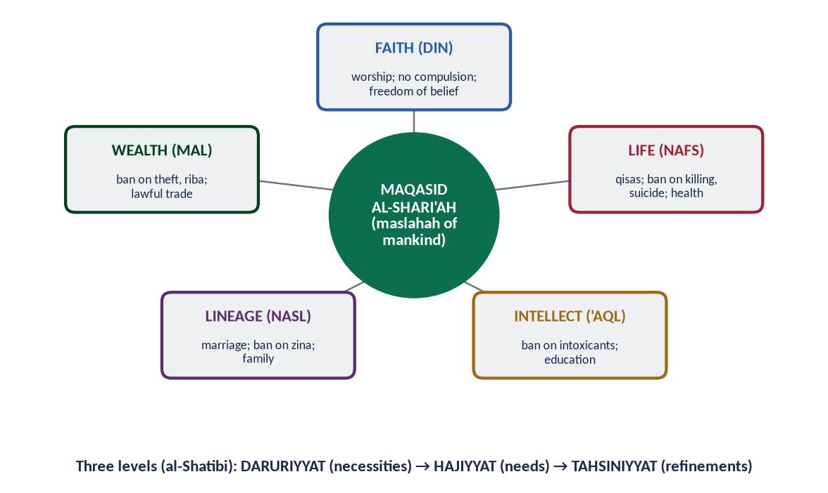
Figure 2 · The five essentials of the Maqasid al-Shari'ah and their three levels.

(1) The five essentials
✦ SCHOLARLY VIEW
Imam al-Ghazali · Al-Mustasfa
“The objective of the Shari'ah is to promote the well-being of all mankind, which lies in safeguarding their faith, their life, their intellect, their posterity and their wealth.”
➜ As translated by M. Umer Chapra. The five essentials (al-daruriyyat al-khams).

Essential | Protected by | Violated by
Faith (din) | Freedom of worship; 'no compulsion' (Al-Baqarah 256) | Forced conversion; mockery of the sacred
Life (nafs) | Qisas (Al-Baqarah 179); health; food security | Murder; suicide; terrorism
Intellect ('aql) | Ban on intoxicants (Al-Ma'idah 90); education | Alcohol, drugs, ignorance
Lineage (nasl) | Marriage; ban on zina (Al-Isra 32) | Adultery; family breakdown
Wealth (mal) | Lawful trade; ban on theft and riba | Theft, fraud, riba, corruption

(2) The three levels (al-Shatibi, Al-Muwafaqat)
- Daruriyyat (necessities) — without them life collapses: the five essentials.
- Hajiyyat (needs) — without them life is hard: concessions such as shortening prayer on a journey.
- Tahsiniyyat (refinements) — they perfect life: cleanliness, good manners, dress.

(3) Why the Maqasid matter today
They guide Ijtihad on new questions, legislation and policy. A law that destroys life, intellect or wealth cannot be Islamic, whatever its label. Modern scholars such as Ibn Ashur added dignity, freedom and justice as objectives.

1.4 How the systems work together
The Islamic systems are one structure, not separate parts:
- Belief gives every system its base. Tawhid makes the ruler a trustee, wealth a trust and justice a duty.
- Worship trains the character that makes the systems work. Prayer builds discipline, fasting self-control, Zakat generosity.
- The social system (family, brotherhood) supports the economic system (Zakat, inheritance).
- The economic system needs the political system (a just state that collects and distributes) and the judicial system (enforcement of contracts, punishment of fraud).
- The administrative system carries all of them out through honest, able officials.
Take one part away and the others weaken. Interest-free banking without honest officials, or Zakat without a trusted state, cannot deliver the promised justice. This is why the syllabus asks for the salient features of the Islamic system as a whole.
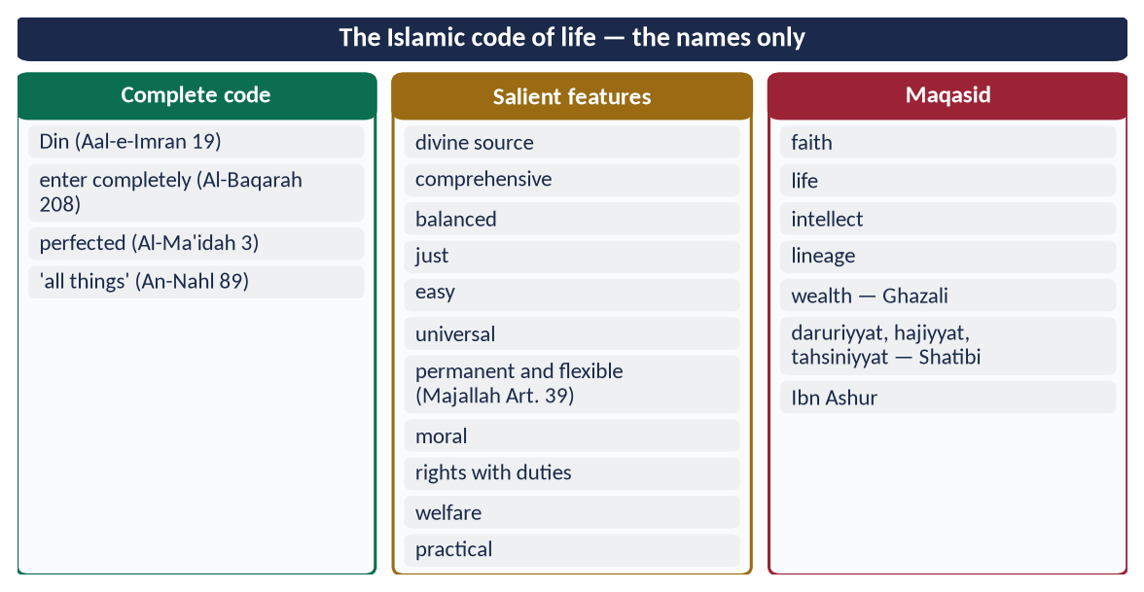
Figure 3 · At a glance — the Islamic code of life — the names only. The detail is in the sections above.

Chapter 2 · The Sources of Islamic Law and the Quran

2.1 The sources — an overview
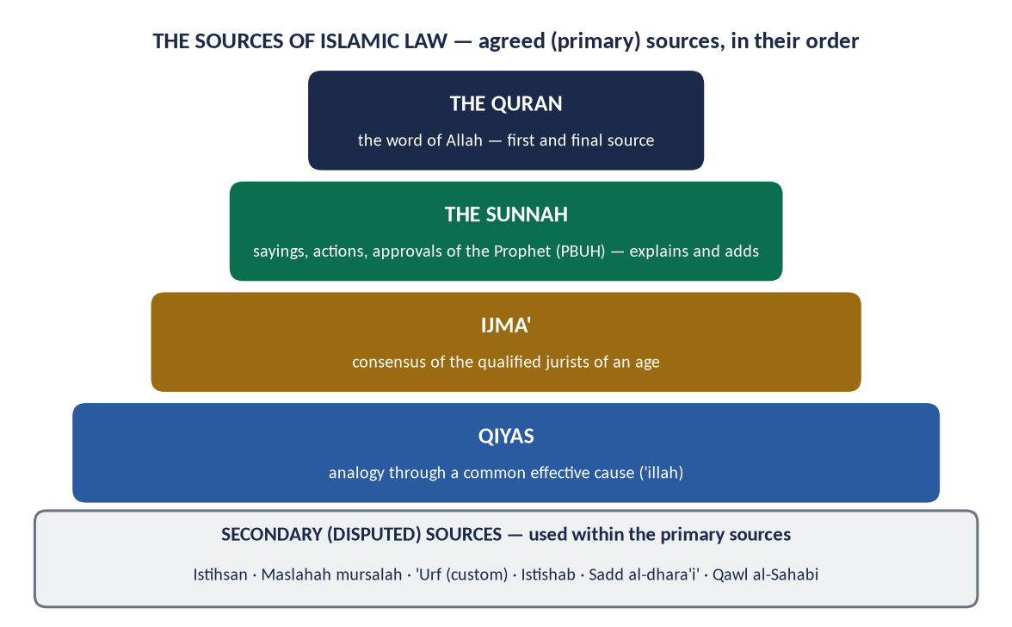
Figure 4 · The sources of Islamic law, in their order.
The jurists agree on four primary sources, used in order: the Quran, the Sunnah, Ijma' and Qiyas. The order is proved by the hadith of Mu'adh ibn Jabal (RA):
✦ HADITH
كَيْفَ تَقْضِي إِذَا عَرَضَ لَكَ قَضَاءٌ؟ قَالَ: أَقْضِي بِكِتَابِ اللَّهِ. قَالَ: فَإِنْ لَمْ تَجِدْ؟ قَالَ: فَبِسُنَّةِ رَسُولِ اللَّهِ. قَالَ: فَإِنْ لَمْ تَجِدْ؟ قَالَ: أَجْتَهِدُ رَأْيِي وَلَا آلُو
“'How will you judge when a case comes to you?' — 'By the Book of Allah.' — 'And if you do not find it there?' — 'By the Sunnah of the Messenger of Allah.' — 'And if you do not find it there?' — 'I will use my own judgement and spare no effort.'” (Abu Dawud and Al-Tirmidhi)
➜ The Prophet ﷺ praised Allah for this answer. Book → Sunnah → reasoned judgement.

✦ QURAN
﴿يَـٰٓأَيُّهَا ٱلَّذِينَ ءَامَنُوٓاْ أَطِيعُواْ ٱللَّهَ وَأَطِيعُواْ ٱلرَّسُولَ وَأُوْلِي ٱلۡأَمۡرِ مِنكُمۡۖ فَإِن تَنَٰزَعۡتُمۡ فِي شَيۡءٖ فَرُدُّوهُ إِلَى ٱللَّهِ وَٱلرَّسُولِ إِن كُنتُمۡ تُؤۡمِنُونَ بِٱللَّهِ وَٱلۡيَوۡمِ ٱلۡأٓخِرِۚ ذَٰلِكَ خَيۡرٞ وَأَحۡسَنُ تَأۡوِيلًا﴾
“O you who believe, obey Allah and obey the Messenger and those in authority among you. If you disagree over anything, refer it to Allah and the Messenger …” (An-Nisa, Quran)
➜ Imam al-Shafi'i drew all four sources from this verse: obey Allah (the Quran), the Messenger (the Sunnah), those in authority (Ijma of the scholars), and refer the dispute back (Qiyas).

2.2 The Quran as the first source

(1) Definition
The Quran is the word of Allah, revealed to the Prophet Muhammad ﷺ in Arabic through Jibril, transmitted by tawatur (mass transmission), written in the mushaf, and recited as worship. It has 114 surahs and about 6,236 verses.

(2) Its authority
✦ QURAN
﴿وَأَنِ ٱحۡكُم بَيۡنَهُم بِمَآ أَنزَلَ ٱللَّهُ وَلَا تَتَّبِعۡ أَهۡوَآءَهُمۡ …﴾
“Judge between them by what Allah has revealed, and do not follow their desires.” (Al-Ma'idah, Quran)
➜ 'Judge between them by what Allah has revealed, and do not follow their desires.'

✦ QURAN
﴿قُلۡ إِنِّي عَلَىٰ بَيِّنَةٖ مِّن رَّبِّي وَكَذَّبۡتُم بِهِۦۚ مَا عِندِي مَا تَسۡتَعۡجِلُونَ بِهِۦٓۚ إِنِ ٱلۡحُكۡمُ إِلَّا لِلَّهِۖ يَقُصُّ ٱلۡحَقَّۖ وَهُوَ خَيۡرُ ٱلۡفَٰصِلِينَ﴾
“Say, "Indeed, I am on clear evidence from my Lord, and you have denied it. I do not have that for which you are impatient. The decision is only for Allah. He relates the truth, and He is the best of deciders.” (Al-An'am, Quran)
➜ 'The judgement is only for Allah.'

Its text is certain in its transmission (qat'i al-thubut). Every other source draws its authority from it.

(3) The legal verses
Of its verses, about 500 deal directly with law (the ayat al-ahkam, as al-Ghazali and others estimated). The rest teach belief, morals, history and the Hereafter, which together form the spirit of the law.
Area | Examples of legal verses
Worship | Prayer (Al-Baqarah 43); fasting (Al-Baqarah 183); Hajj (Aal-e-Imran 97)
Family | Marriage and divorce (Al-Baqarah 228–241); inheritance (An-Nisa 11–12, 176)
Economy | Riba (Al-Baqarah 275–280); contracts (Al-Baqarah 282); Zakat (At-Tawbah 60)
Crime | Theft (Al-Ma'idah 38); qisas (Al-Baqarah 178–179); hirabah (Al-Ma'idah 33)
State | Justice and trusts (An-Nisa 58–59); shura (Ash-Shura 38)
International | War and treaties (Al-Anfal 61; At-Tawbah 4)

(4) The features of Quranic legislation
- General principles rather than detail, which leaves room for Sunnah and Ijtihad.
- Few obligations — 'Do not ask about things which, if made clear to you, would trouble you' (Al-Ma'idah 101).
- Ease (Al-Baqarah 185).
- Gradual legislation (tadrij). Wine was forbidden in four stages: An-Nahl 67 (a hint), Al-Baqarah 219 (sin greater than benefit), An-Nisa 43 (not near prayer while intoxicated), and Al-Ma'idah 90 (final prohibition).
- Reasons given for many rulings, which makes Qiyas possible: 'that you may attain taqwa' (Al-Baqarah 183).

(5) Certain and probable meaning
- Qat'i al-dalalah (certain in meaning) — e.g. the shares of inheritance. There is no Ijtihad against it.
- Zanni al-dalalah (open to interpretation) — e.g. 'three quru'' in Al-Baqarah 228: menstrual periods (Hanafi) or states of purity (Shafi'i). Ijtihad works here.

(6) Abrogation (naskh)
Some rulings were replaced by later revelation during the Prophet's ﷺ lifetime, as the community matured. An example is the waiting period of a widow, first a year (Al-Baqarah 240), then four months and ten days (Al-Baqarah 234).
✦ QURAN
﴿مَا نَنسَخۡ مِنۡ ءَايَةٍ أَوۡ نُنسِهَا نَأۡتِ بِخَيۡرٖ مِّنۡهَآ أَوۡ مِثۡلِهَآۗ أَلَمۡ تَعۡلَمۡ أَنَّ ٱللَّهَ عَلَىٰ كُلِّ شَيۡءٖ قَدِيرٌ﴾
“We do not abrogate a verse or cause it to be forgotten except that We bring forth [one] better than it or similar to it. Do you not know that Allah is over all things competent.” (Al-Baqarah, Quran)
➜ 'We do not abrogate a verse or cause it to be forgotten except that We bring one better than it or similar to it.'

Naskh ended with the Prophet's ﷺ death. No scholar, ruler or parliament can abrogate a ruling after him. A mujtahid must know which rulings were abrogated before deriving law.

2.3 How the sources work together
The sources are not rivals but a single system:
- the Quran gives the principles;
- the Sunnah explains and applies them;
- Ijma settles their meaning for the community;
- Qiyas extends them to new cases through their causes.
Every later source must rest on an earlier one. Ijma needs a basis (sanad) in the texts; Qiyas needs an original case in the texts. Behind all of them stands the Maqasid: the purposes that the whole law serves.
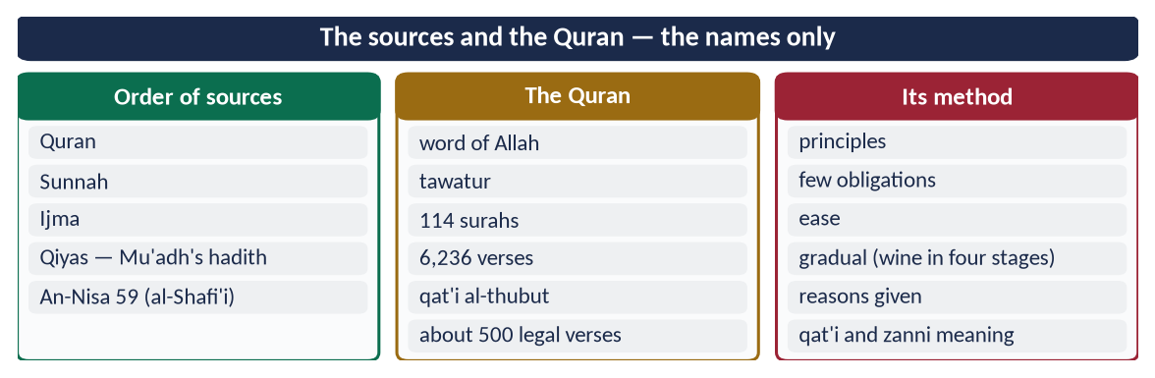
Figure 5 · At a glance — the sources and the Quran — the names only. The detail is in the sections above.

Chapter 3 · The Sunnah: Its Importance in Interpretation and Legislation
The direct subject of 2015: 'Write a comprehensive note on the importance of Sunnah in interpretation and legislation.'

3.1 Meaning
- Literally, sunnah (سُنَّة) means a path or practice.
- Technically, it is everything reported from the Prophet ﷺ:
- his sayings (qawl);
- his actions (fi'l);
- his tacit approvals (taqrir) — what was done before him and he did not object to.
- Hadith is the report; Sunnah is the practice it records.

3.2 The authority of the Sunnah — from the Quran
✦ QURAN
﴿… كَيۡ لَا يَكُونَ دُولَةَۢ بَيۡنَ ٱلۡأَغۡنِيَآءِ مِنكُمۡۚ …﴾
“… so that it does not circulate only among the rich among you.” (Al-Hashr, Quran)
➜ 'Whatever the Messenger gives you, take it; and whatever he forbids you, refrain from it.'

✦ QURAN
﴿مَّن يُطِعِ ٱلرَّسُولَ فَقَدۡ أَطَاعَ ٱللَّهَۖ وَمَن تَوَلَّىٰ فَمَآ أَرۡسَلۡنَٰكَ عَلَيۡهِمۡ حَفِيظٗا﴾
“He who obeys the Messenger has obeyed Allah; but those who turn away - We have not sent you over them as a guardian.” (An-Nisa, Quran)
➜ 'Whoever obeys the Messenger has obeyed Allah.'

✦ QURAN
﴿وَمَا يَنطِقُ عَنِ ٱلۡهَوَىٰٓ ۝ إِنۡ هُوَ إِلَّا وَحۡيٞ يُوحَىٰ﴾
“Nor does he speak from [his own] inclination. It is not but a revelation revealed.” (An-Najm, Quran)
➜ Nor does he speak from his own desire. It is nothing but revelation revealed.

✦ QURAN
﴿بِٱلۡبَيِّنَٰتِ وَٱلزُّبُرِۗ وَأَنزَلۡنَآ إِلَيۡكَ ٱلذِّكۡرَ لِتُبَيِّنَ لِلنَّاسِ مَا نُزِّلَ إِلَيۡهِمۡ وَلَعَلَّهُمۡ يَتَفَكَّرُونَ﴾
“[We sent them] with clear proofs and written ordinances. And We revealed to you the message that you may make clear to the people what was sent down to them and that they might give thought.” (An-Nahl, Quran)
➜ We sent down to you the Reminder so that you may make clear to people what was sent down to them.

✦ QURAN
﴿فَلَا وَرَبِّكَ لَا يُؤۡمِنُونَ حَتَّىٰ يُحَكِّمُوكَ فِيمَا شَجَرَ بَيۡنَهُمۡ ثُمَّ لَا يَجِدُواْ فِيٓ أَنفُسِهِمۡ حَرَجٗا مِّمَّا قَضَيۡتَ وَيُسَلِّمُواْ تَسۡلِيمٗا﴾
“But no, by your Lord, they will not [truly] believe until they make you, [O Muhammad], judge concerning that over which they dispute among themselves and then find within themselves no discomfort from what you have judged and submit in [full, willing] submission.” (An-Nisa, Quran)
➜ By your Lord, they will not truly believe until they make you judge in their disputes and find no resentment in themselves.

✦ QURAN
﴿لَّقَدۡ كَانَ لَكُمۡ فِي رَسُولِ ٱللَّهِ أُسۡوَةٌ حَسَنَةٞ لِّمَن كَانَ يَرۡجُواْ ٱللَّهَ وَٱلۡيَوۡمَ ٱلۡأٓخِرَ وَذَكَرَ ٱللَّهَ كَثِيرٗا﴾
“There has certainly been for you in the Messenger of Allah an excellent pattern for anyone whose hope is in Allah and the Last Day and [who] remembers Allah often.” (Al-Ahzab, Quran)
➜ 'There has certainly been for you in the Messenger of Allah an excellent example.'

3.3 The authority of the Sunnah — from the Sunnah itself
✦ HADITH
أَلَا إِنِّي أُوتِيتُ الْقُرْآنَ وَمِثْلَهُ مَعَهُ
“Indeed, I have been given the Quran and something like it along with it.” (Abu Dawud)
➜ The Prophet ﷺ warned against those who would say, 'Only the Quran is binding on us.'

✦ HADITH
تَرَكْتُ فِيكُمْ أَمْرَيْنِ لَنْ تَضِلُّوا مَا تَمَسَّكْتُمْ بِهِمَا: كِتَابَ اللَّهِ وَسُنَّةَ نَبِيِّهِ
“I have left among you two things; you will not go astray as long as you hold to them: the Book of Allah and the Sunnah of His Prophet.” (Al-Muwatta' (Malik))

3.4 The importance of the Sunnah in interpretation (tafsir)
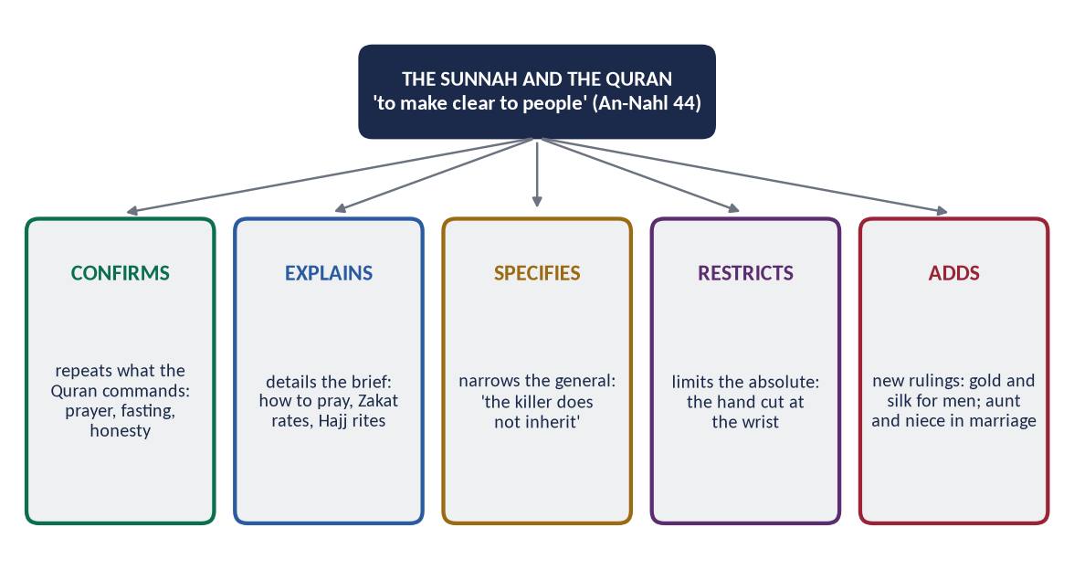
Figure 6 · The five roles of the Sunnah in relation to the Quran.

(1) It explains the brief (bayan al-mujmal)
The Quran says 'establish prayer', but not how. The Sunnah gives:
- the times, the number of rak'ahs and the method — 'Pray as you have seen me praying' (Al-Bukhari);
- the rates and nisab of Zakat;
- the rites of Hajj — 'Take your rites from me' (Muslim).

(2) It specifies the general (takhsis al-'amm)
- The Quran gives children inheritance in general terms (An-Nisa 11). The Sunnah excludes the killer: 'The killer does not inherit' (Al-Tirmidhi).

(3) It restricts the absolute (taqyid al-mutlaq)
- 'Cut off the hand of the thief' (Al-Ma'idah 38) does not say where. The Sunnah fixes the wrist and a minimum value (nisab).

(4) It explains words and concepts
- 'Zulm' in Al-An'am 82 ('those who do not mix their faith with zulm'). The Companions were troubled, thinking it meant any wrong. The Prophet ﷺ explained that it means shirk, citing Luqman 13 (Al-Bukhari).
- 'The middle prayer' (Al-Baqarah 238) is explained as 'Asr (Al-Bukhari and Muslim).

(5) It confirms (ta'kid)
It repeats and stresses the Quran's commands: honesty, kindness to parents, the prohibition of murder.

3.5 The importance of the Sunnah in legislation (tashri')
The Sunnah also gives independent rulings (al-sunnah al-mustaqillah) on which the Quran is silent:
- the prohibition of marrying a woman and her paternal or maternal aunt together (Al-Bukhari and Muslim);
- gold and silk forbidden for men (Al-Tirmidhi; Al-Nasa'i);
- the grandmother's share of one-sixth (Abu Dawud; confirmed by Abu Bakr (RA) after asking the Companions);
- the prohibition of domestic donkeys' meat and of predatory animals (Al-Bukhari and Muslim);
- Zakat al-Fitr (Al-Bukhari and Muslim);
- detailed rules of trade — no sale of what you do not own, no gharar (Muslim).

3.6 The Sunnah as the living model
The Sunnah turns the law into practice. The Quran commands justice; the Prophet ﷺ showed it in his judgements, his treaties, his treatment of his wives, his neighbours and his enemies. Without the Sunnah, the Quran's commands would stay abstract. The Companions understood this: Umar (RA) said, 'People will come who argue with you using the ambiguous verses of the Quran. Take hold of them with the Sunnah, for the people of the Sunnah know the Book of Allah best' (Al-Darimi).

3.7 The preservation of the Sunnah
- Memorisation and writing in the Prophet's ﷺ life: 'Abdullah ibn 'Amr (RA) wrote his Al-Sahifah al-Sadiqah.
- Official collection: Caliph Umar ibn Abd al-Aziz (about 100 AH) ordered the hadith to be collected, through Ibn Shihab al-Zuhri and Abu Bakr ibn Hazm.
- The science of isnad (chains of narrators) and 'ilm al-rijal (biography of narrators) — unmatched in the history of any religion.
- The great collections: Al-Muwatta' of Imam Malik; the Sahih of Al-Bukhari (d. 870) and of Muslim (d. 875); the Sunan of Abu Dawud, Al-Tirmidhi, Al-Nasa'i and Ibn Majah — together the Sihah Sittah.

3.7a The kinds of hadith — which Sunnah is a proof?
Kind | Meaning and legal weight
Mutawatir | Reported by so many at every stage that a lie is impossible — certain, like the Quran (e.g. the number of daily prayers)
Ahad | Reported by fewer narrators — a binding proof in practical law when authentic, as the majority hold
Sahih (authentic) | Continuous chain of upright, precise narrators, free of defects — accepted
Hasan (good) | Like sahih, with slightly less precise narrators — accepted
Da'if (weak) | A defect in the chain or text — not a basis for law
Mawdu' (fabricated) | Falsely attributed — rejected; 'whoever lies about me deliberately, let him take his seat in the Fire' (Al-Bukhari and Muslim)

3.8 The Sunnah in Pakistan's law
Article 227 of the Constitution requires all laws to conform to the 'Quran and Sunnah'. The Federal Shariat Court (Article 203) tests laws against both. The Sunnah is thus a living source of Pakistani legislation.

3.9 The modern denial of hadith — a short answer
Some modern voices say the Quran alone is enough. The answer:
- (a) the Quran itself commands obedience to the Messenger (An-Nisa 80; Al-Hashr 7);
- (b) prayer, Zakat and Hajj cannot be performed from the Quran alone;
- (c) the Prophet ﷺ foretold this claim ('I have been given the Quran and something like it');
- (d) the science of hadith separates the authentic from the weak with rigorous method.
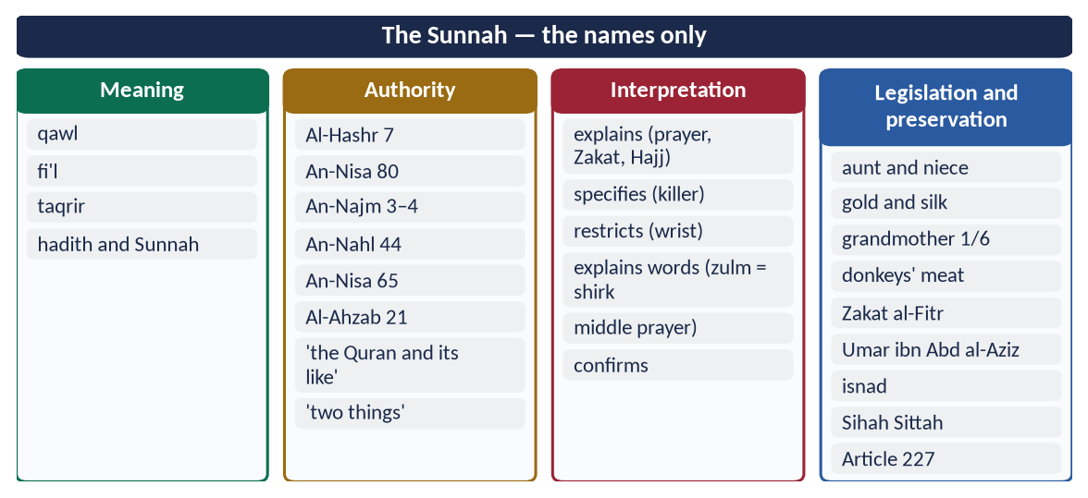
Figure 7 · At a glance — the Sunnah — the names only. The detail is in the sections above.

Chapter 4 · Ijma: Definition, Kinds, Procedure — and Parliament
The subject of 2017 ('Define Ijma' and explain its different kinds. Highlight its importance in the light of the Qur'an and Sunnah') and 2023 ('… Can legislation by a parliament of an Islamic state be regarded as a valid consensus?').

4.1 Definition
- Literally, ijma' (إِجْمَاع) means (a) firm resolve — 'so resolve upon your plan' (Yunus 71: فَأَجْمِعُوا أَمْرَكُمْ) — and (b) agreement.
- Technically: Ijma' is the agreement of all the mujtahids of the Ummah of Muhammad ﷺ, in any age after his death, on a legal ruling (hukm shar'i).

The elements of the definition
- (a) Mujtahids — qualified jurists, not the general public.
- (b) All of them — unanimity; the majority view holds that one qualified dissent prevents Ijma.
- (c) Of the Ummah of Muhammad ﷺ.
- (d) After his death — in his lifetime the Sunnah itself was the authority.
- (e) On a shar'i ruling.
- (f) With a basis (sanad) in the Quran, Sunnah or Qiyas — Ijma does not invent law from nothing.

4.2 The authority of Ijma — the Quran
✦ QURAN
﴿وَمَن يُشَاقِقِ ٱلرَّسُولَ مِنۢ بَعۡدِ مَا تَبَيَّنَ لَهُ ٱلۡهُدَىٰ وَيَتَّبِعۡ غَيۡرَ سَبِيلِ ٱلۡمُؤۡمِنِينَ نُوَلِّهِۦ مَا تَوَلَّىٰ وَنُصۡلِهِۦ جَهَنَّمَۖ وَسَآءَتۡ مَصِيرًا﴾
“And whoever opposes the Messenger after guidance has become clear to him and follows other than the way of the believers - We will give him what he has taken and drive him into Hell, and evil it is as a destination.” (An-Nisa, Quran)
➜ Whoever opposes the Messenger after guidance has become clear to him, and follows other than the way of the believers, We will give him what he has taken and drive him into Hell.

✦ QURAN
﴿وَكَذَٰلِكَ جَعَلۡنَٰكُمۡ أُمَّةٗ وَسَطٗا لِّتَكُونُواْ شُهَدَآءَ عَلَى ٱلنَّاسِ وَيَكُونَ ٱلرَّسُولُ عَلَيۡكُمۡ شَهِيدٗاۗ …﴾
“And thus We have made you a middle (just) nation, that you may be witnesses over mankind and the Messenger a witness over you.” (Al-Baqarah, Quran)
➜ 'We have made you a middle (just) nation, that you may be witnesses over mankind.'

✦ QURAN
﴿كُنتُمۡ خَيۡرَ أُمَّةٍ أُخۡرِجَتۡ لِلنَّاسِ تَأۡمُرُونَ بِٱلۡمَعۡرُوفِ وَتَنۡهَوۡنَ عَنِ ٱلۡمُنكَرِ وَتُؤۡمِنُونَ بِٱللَّهِۗ …﴾
“You are the best nation brought forth for mankind: you enjoin what is right, forbid what is wrong, and believe in Allah.” (Aal-e-Imran, Quran)
➜ 'You are the best nation raised for mankind: you enjoin right and forbid wrong.'

✦ QURAN
﴿وَٱعۡتَصِمُواْ بِحَبۡلِ ٱللَّهِ جَمِيعٗا وَلَا تَفَرَّقُواْۚ وَٱذۡكُرُواْ نِعۡمَتَ ٱللَّهِ عَلَيۡكُمۡ إِذۡ كُنتُمۡ أَعۡدَآءٗ فَأَلَّفَ بَيۡنَ قُلُوبِكُمۡ فَأَصۡبَحۡتُم بِنِعۡمَتِهِۦٓ إِخۡوَٰنٗا …﴾
“And hold firmly to the rope of Allah all together and do not become divided. Remember Allah's favour upon you: you were enemies, and He brought your hearts together, and by His favour you became brothers.” (Aal-e-Imran, Quran)
➜ 'Hold fast to the rope of Allah all together and do not be divided.'

4.3 The authority of Ijma — the Sunnah
✦ HADITH
إِنَّ أُمَّتِي لَا تَجْتَمِعُ عَلَى ضَلَالَةٍ
“My Ummah will not agree upon misguidance.” (Ibn Majah)
➜ Reported through several chains, which strengthen one another (also Al-Tirmidhi, with 'Allah's hand is over the jama'ah').

✦ HADITH
إِنَّ اللَّهَ لَا يَجْمَعُ أُمَّتِي عَلَى ضَلَالَةٍ، وَيَدُ اللَّهِ مَعَ الْجَمَاعَةِ
“Allah will not gather my Ummah upon misguidance, and the hand of Allah is with the jama'ah.” (Al-Tirmidhi)

✦ HADITH
مَنْ فَارَقَ الْجَمَاعَةَ شِبْرًا فَمَاتَ، فَمِيتَةٌ جَاهِلِيَّةٌ
“Whoever separates from the community by a hand-span and dies, dies a death of Jahiliyyah.” (Al-Bukhari and Muslim)

4.4 The kinds of Ijma

(1) By the way it is expressed
- Explicit Ijma (sarih / qawli) — every mujtahid states his view, in words or by practice, and all agree. It is the strongest, and is certain (qat'i).
- Tacit Ijma (sukuti) — some mujtahids state a view, it becomes known, and the rest remain silent without objecting, after time to reflect. The Hanafis accept it as proof. Al-Shafi'i, in his well-known view, did not treat it as certain. It is weaker (zanni).

(2) By its period and people
- Ijma of the Companions — accepted by all schools; the strongest in practice.
- Ijma of the mujtahids of any later age — accepted by the majority.
- Ijma of the people of Madinah ('amal ahl al-Madinah) — Imam Malik treated their practice as authoritative; others did not.

(3) By its certainty
- Qat'i — explicit Ijma transmitted by mass transmission (tawatur); denying it is grave.
- Zanni — tacit Ijma, or Ijma reported by few narrators.

4.5 Examples of Ijma
Matter | The consensus
Election of Abu Bakr (RA) | The Companions agreed on his Caliphate after Saqifah (11 AH)
Compilation of the Quran | Abu Bakr's collection (12 AH) and Uthman's standard copy were accepted by all the Companions
The grandmother's share | One-sixth, after al-Mughirah and Muhammad ibn Maslamah reported the Prophet's ﷺ ruling
Fighting those who refused Zakat | After debate, the Companions agreed with Abu Bakr
Marriage to a grandmother | Forbidden, by extending 'your mothers' (An-Nisa 23)
The five daily prayers and their rak'ahs | Agreed practice passed down in every generation

4.6 Its importance
- (a) It secures the Ummah's unity. Settled questions are not reopened in every generation.
- (b) It fixes the meaning of texts that could be read in several ways.
- (c) It protects the religion from individual error — a safeguard the Prophet ﷺ promised.
- (d) It is the bridge between the texts and the life of the community.
- (e) It makes law collective, not the opinion of one scholar or ruler.
- (f) It answers new questions when joined to collective Ijtihad.

4.7 The procedure of Ijma

(1) In the classical age
There was no formal institution. Consensus was known by:
- the Caliph consulting the Companions in Madinah — Abu Bakr asked, 'Does anyone know a ruling of the Prophet ﷺ on this?';
- scholars learning one another's views through travel, letters and books;
- later jurists recording where there was agreement and where there was difference (e.g. Ibn al-Mundhir's Kitab al-Ijma').

(2) In the modern age — collective Ijtihad
The Ummah is now spread across dozens of states, so full Ijma of every mujtahid is almost impossible to verify. Its modern form is collective Ijtihad (al-ijtihad al-jama'i) through academies:
Body | Role
International Islamic Fiqh Academy (OIC, Jeddah; created 1981) | Jurists from member states issue joint resolutions — e.g. on takaful (1985), organ transplantation (1988), human cloning (1997)
Islamic Fiqh Council (Muslim World League, Makkah) | Joint rulings on contemporary questions
Council of Islamic Ideology (Pakistan; Articles 228–231) | Advises Parliament whether laws are Islamic
Federal Shariat Court (Pakistan; Article 203) | Tests laws against the Quran and Sunnah

4.8 Can a parliament's legislation be a valid consensus? (2023)

(1) The case for — Iqbal's view
✦ SCHOLARLY VIEW
Allama Muhammad Iqbal · The Reconstruction of Religious Thought in Islam, Lecture VI
“The transfer of the power of Ijtihad from individual representatives of schools to a Muslim legislative assembly which, in view of the growth of opposing sects, is the only possible form Ijma can take in modern times, will secure contributions to legal discussion from laymen who happen to possess a keen insight into affairs.”
➜ Iqbal also proposed that scholars of the law should sit in or guide such an assembly, to prevent errors of interpretation.

- An elected assembly represents the Ummah's consent, the collective 'way of the believers' (An-Nisa 115).
- It is a form of Shura (Ash-Shura 38).
- It can join experts (economists, doctors, engineers) with scholars — what modern questions need.

(2) The case against — why it is not classical Ijma
- Members are not mujtahids. Classical Ijma requires qualified jurists.
- Majority, not unanimity. A law passed 60–40 is not consensus.
- One country, not the Ummah. Ijma is of the whole Ummah's jurists.
- It can be changed by the next parliament. Classical Ijma is binding and settled.
- It may contradict texts. No vote can make halal what the Quran made haram.

(3) A balanced answer
Parliamentary legislation is not Ijma in the classical, binding sense. It can be a valid collective Ijtihad — a modern, national form of the principle behind Ijma — if four conditions hold:
- (a) it stays within the Quran and Sunnah (Article 227);
- (b) it is prepared with the advice of qualified scholars (the CII) and experts;
- (c) it can be reviewed by a court (the Federal Shariat Court);
- (d) it is passed by broad agreement, not a narrow majority.

(4) Pakistani examples
- The Objectives Resolution (1949), passed by the Constituent Assembly.
- The 22 points of 31 ulema (January 1951) — scholars of all schools agreed on the basic principles of an Islamic state; an example of inter-school consensus.
- The 1973 Constitution, adopted by a broad consensus of the elected assembly, with its Islamic provisions (Articles 2, 2A, 31, 227–231).

4.9 Ijma and difference of opinion (ikhtilaf)
Where there is no Ijma, the jurists may differ, and differences in Ijtihad are a mercy, not a sin. The four schools differ on hundreds of details while agreeing on the fundamentals. Imam Malik refused Caliph Harun al-Rashid's offer to impose his Muwatta' on the whole empire, saying the Companions had spread to many lands with their knowledge. The rule is: respect settled Ijma; tolerate reasoned difference. Neither side of a reasoned difference should be declared sinful, still less outside Islam.
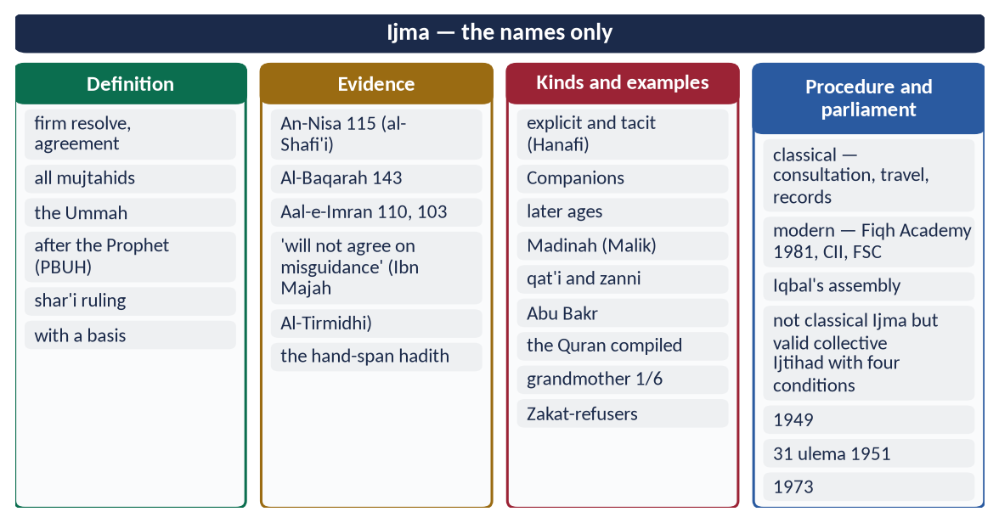
Figure 8 · At a glance — ijma — the names only. The detail is in the sections above.

Chapter 5 · Qiyas and the Secondary Sources

5.1 Qiyas — definition
- Literally, qiyas (قِيَاس) means measuring or comparing.
- Technically, it is extending the ruling of an original case, established by text, to a new case, because both share the same effective cause ('illah) that cannot be known by language alone.

5.2 The four pillars (arkan)
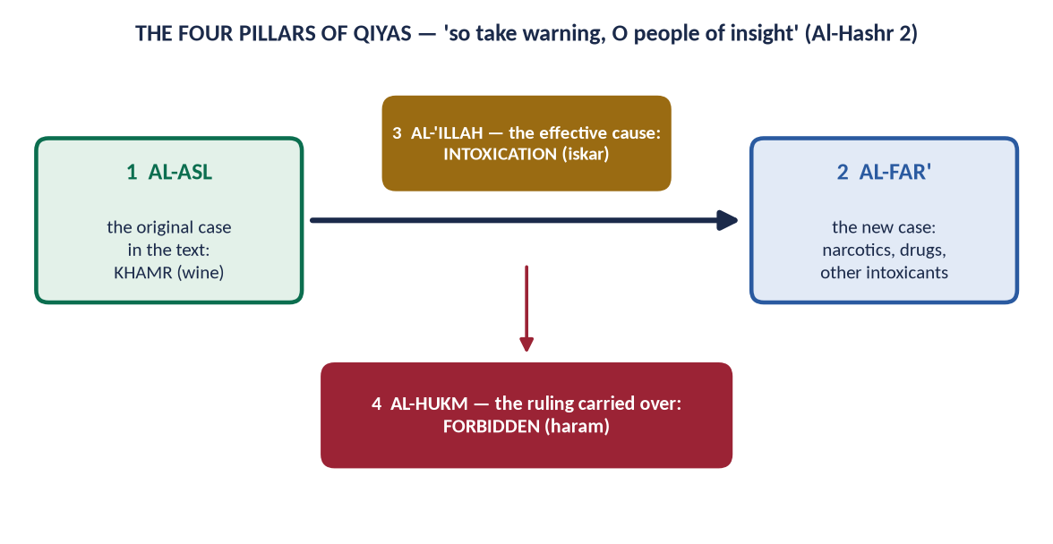
Figure 9 · The four pillars of Qiyas, with the classical example.
- (1) Al-Asl — the original case in the text: wine (khamr).
- (2) Al-Far' — the new case: narcotics and other intoxicants.
- (3) Al-Hukm — the ruling of the original: forbidden (Al-Ma'idah 90).
- (4) Al-'Illah — the effective cause shared by both: intoxication (iskar). The Prophet ﷺ said, 'Every intoxicant is khamr, and every intoxicant is forbidden' (Muslim).

5.3 The authority of Qiyas
✦ QURAN
﴿… فَٱعۡتَبِرُواْ يَـٰٓأُوْلِي ٱلۡأَبۡصَٰرِ﴾
“So take warning, O people of insight.” (Al-Hashr, Quran)
➜ 'So take warning (fa'tabiru), O people of insight.'

✦ QURAN
﴿… وَلَوۡ رَدُّوهُ إِلَى ٱلرَّسُولِ وَإِلَىٰٓ أُوْلِي ٱلۡأَمۡرِ مِنۡهُمۡ لَعَلِمَهُ ٱلَّذِينَ يَسۡتَنۢبِطُونَهُۥ مِنۡهُمۡۗ …﴾
“If they had referred it to the Messenger and to those in authority among them, those who can draw conclusions from it would have known it.” (An-Nisa, Quran)
➜ If they had referred it to the Messenger and to those in authority among them, those who can draw conclusions (yastanbitunahu) would have known it.

- Mu'adh's hadith — 'I will use my own judgement' (Abu Dawud; Al-Tirmidhi).
- The Prophet ﷺ used analogy. A woman asked whether she could perform Hajj for her dead mother. He replied, 'If your mother had a debt, would you not pay it? Pay the debt of Allah, for Allah is more entitled to be paid' (Al-Bukhari).
- Umar's letter to Abu Musa: 'Know the likenesses and similarities, and compare matters' (Al-Daraqutni).
- The Companions reasoned by analogy. They compared the Caliphate to the Prophet's ﷺ appointing Abu Bakr to lead the prayer: 'He was pleased with him for our religion; shall we not be pleased with him for our world?'

5.4 The conditions of the 'illah
- Apparent (zahir) — it can be seen and checked.
- Constant (mundabit) — it does not change with persons and places.
- Relevant (munasib) — reasonably linked to the purpose of the ruling.
- Not limited to the original case — otherwise there is nothing to extend.
- Qiyas cannot oppose a text or Ijma.

5.5 Examples
Original (text) | Extended by Qiyas
Wine forbidden — 'illah: intoxication | Narcotics, drugs, all intoxicants
'The killer does not inherit' | A killer does not receive a bequest from his victim
Trade forbidden at the time of the Friday call (Al-Jumu'ah 9) — 'illah: distraction from prayer | Any contract or activity that distracts from the Friday prayer
Riba in six items (gold, silver, wheat, barley, dates, salt) | The Hanafis extend it by weight or measure plus same kind; others by other 'illahs — hence currency notes

5.5a The importance of Qiyas
- It extends the texts to new cases. Narcotics, new drinks and modern contracts are judged by the causes behind the Quran's rulings.
- It shows that the law is reasoned. Rulings have purposes that the mind can grasp.
- It unites text and reason. Qiyas always starts from a text, so reason serves revelation rather than replacing it.
- It is the main tool of Ijtihad. Most of the fiqh of the four schools was built by it.

5.6 The secondary sources

(1) Istihsan (اِسْتِحْسَان) — juristic preference (Hanafi)
Leaving a strict analogy for a stronger reason: a text, Ijma, necessity or public benefit. Example: the istisna' (manufacturing) contract. It is a sale of something not yet in existence, which strict analogy would forbid, but it is allowed because people need it and have always practised it. Imam Abu Hanifah was known for it.

(2) Maslahah mursalah (مَصْلَحَة مُرْسَلَة) — public interest (Maliki)
A benefit that no text specifically approves or rejects, but which serves the Maqasid. Examples:
- the compilation of the Quran by Abu Bakr;
- Umar's Diwan and prisons;
- today's traffic laws, registration of marriages, and company law.

(3) 'Urf (عُرْف) — custom
Custom that does not contradict the text is authoritative: 'Custom is authoritative' (العَادَةُ مُحَكَّمَةٌ). Example: the amount of maintenance (nafaqah) and mahr customs; trade usages.

(4) Istishab (اِسْتِصْحَاب) — presumption of continuity
A state known to exist continues until proved otherwise. Examples: a person is innocent until proved guilty; a missing person is presumed alive; things are permissible until proved forbidden.

(5) Sadd al-dhara'i' (سَدُّ الذَّرَائِع) — blocking the means
A lawful act that usually leads to harm may be prevented.
✦ QURAN
﴿وَلَا تَسُبُّواْ ٱلَّذِينَ يَدۡعُونَ مِن دُونِ ٱللَّهِ فَيَسُبُّواْ ٱللَّهَ عَدۡوَۢا بِغَيۡرِ عِلۡمٖۗ …﴾
“Do not insult those they invoke besides Allah, lest they insult Allah in enmity, without knowledge.” (Al-An'am, Quran)
➜ 'Do not insult those they invoke besides Allah, lest they insult Allah in enmity without knowledge.'

(6) Qawl al-Sahabi — the opinion of a Companion
The Hanafis give weight to a Companion's opinion where there is no text, since the Companions saw the revelation.

(7) Shar' man qablana — the laws of earlier prophets
Binding if the Quran or Sunnah reports them without cancelling them — e.g. qisas (Al-Ma'idah 45).
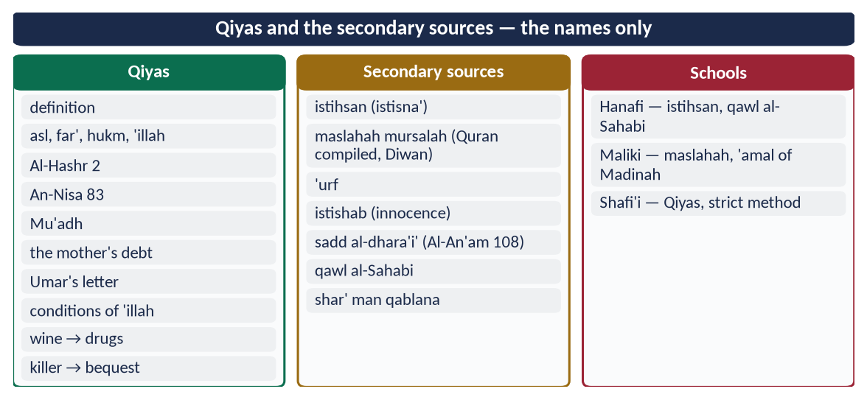
Figure 10 · At a glance — qiyas and the secondary sources — the names only. The detail is in the sections above.

Chapter 6 · Ijtihad: Concept, Conditions, Principles and Contemporary Importance
Asked twice: 2018 ('Define Ijtihad, also highlight its contemporary importance in the light of Islamic Fiqh') and 2022 ('Elaborate the concept and importance of Ijtihad and explain its principles').

6.1 The concept of Ijtihad
- Literally, ijtihad (اِجْتِهَاد) comes from juhd (جُهْد), effort. It means exerting oneself to the utmost in a difficult task. It is not used for easy things: one says 'he exerted himself to carry a millstone', not 'to carry a feather'.
- Technically, it is the utmost effort of a qualified jurist (mujtahid) to derive a practical legal ruling from its detailed evidences.
- Iqbal called it 'the principle of movement in the structure of Islam' (Reconstruction, Lecture VI).

6.2 The authority of Ijtihad
✦ QURAN
﴿… وَلَوۡ رَدُّوهُ إِلَى ٱلرَّسُولِ وَإِلَىٰٓ أُوْلِي ٱلۡأَمۡرِ مِنۡهُمۡ لَعَلِمَهُ ٱلَّذِينَ يَسۡتَنۢبِطُونَهُۥ مِنۡهُمۡۗ …﴾
“If they had referred it to the Messenger and to those in authority among them, those who can draw conclusions from it would have known it.” (An-Nisa, Quran)
➜ If they had referred it to the Messenger and to those in authority among them, those who can draw conclusions from it (yastanbitunahu) would have known it.

✦ QURAN
﴿وَمَا كَانَ ٱلۡمُؤۡمِنُونَ لِيَنفِرُواْ كَآفَّةٗۚ فَلَوۡلَا نَفَرَ مِن كُلِّ فِرۡقَةٖ مِّنۡهُمۡ طَآئِفَةٞ لِّيَتَفَقَّهُواْ فِي ٱلدِّينِ وَلِيُنذِرُواْ قَوۡمَهُمۡ إِذَا رَجَعُوٓاْ إِلَيۡهِمۡ لَعَلَّهُمۡ يَحۡذَرُونَ﴾
“And it is not for the believers to go forth [to battle] all at once. For there should separate from every division of them a group [remaining] to obtain understanding in the religion and warn their people when they return to them that they might be cautious.” (At-Tawbah, Quran)
➜ Why should not a party from every group go forth to gain understanding (li-yatafaqqahu) in religion, and warn their people when they return?

✦ QURAN
﴿… فَٱعۡتَبِرُواْ يَـٰٓأُوْلِي ٱلۡأَبۡصَٰرِ﴾
“So take warning, O people of insight.” (Al-Hashr, Quran)
➜ 'So take warning, O people of insight.'

✦ HADITH
إِذَا حَكَمَ الْحَاكِمُ فَاجْتَهَدَ ثُمَّ أَصَابَ فَلَهُ أَجْرَانِ، وَإِذَا حَكَمَ فَاجْتَهَدَ ثُمَّ أَخْطَأَ فَلَهُ أَجْرٌ
“When a judge rules, having striven (ijtahada), and is right, he has two rewards; and if he strives and errs, he has one reward.” (Al-Bukhari and Muslim)
➜ Ijtihad is rewarded even when it errs — a strong encouragement to disciplined reasoning.

✦ HADITH
أَجْتَهِدُ رَأْيِي وَلَا آلُو
“'I will use my own judgement and spare no effort.'” (Abu Dawud and Al-Tirmidhi)
➜ Mu'adh ibn Jabal's (RA) answer, approved by the Prophet ﷺ.

The Prophet's ﷺ approval of the Companions' Ijtihad
- Banu Qurayzah (5 AH): 'None of you should pray 'Asr except at Banu Qurayzah.' Some prayed on the way when the time was running out; others delayed. The Prophet ﷺ blamed neither group (Al-Bukhari).
- 'Amr ibn al-'As (RA) made tayammum instead of ghusl on a freezing night, citing 'do not kill yourselves' (An-Nisa 29). The Prophet ﷺ smiled and approved (Abu Dawud).

6.3 The Ijtihad of the Rightly-Guided Caliphs
- Abu Bakr (RA): compiling the Quran; fighting the Zakat-refusers.
- Umar (RA):
- kept the conquered lands of Iraq as state land;
- suspended the punishment of theft in the famine year;
- stopped the share of 'those whose hearts are to be reconciled' (mu'allafat al-qulub) when Islam no longer needed it — the 'illah had ended;
- set up the Diwan.
- Uthman (RA): the standard copy of the Quran; the second call on Friday as Madinah grew.
- Ali (RA): the minimum period of pregnancy from two verses.

6.4 The conditions of a mujtahid
Condition | Why
Arabic language | The Quran and Sunnah are in Arabic; grammar and rhetoric decide meaning
The Quran — especially the legal verses (about 500) | With their context, the abrogating and abrogated (nasikh–mansukh), the general and specific
The Sunnah — the legal hadith | With the science of authenticity
Ijma | So that he does not contradict a settled consensus
Usul al-Fiqh and Qiyas | The method of deriving law
Maqasid al-Shari'ah | Al-Shatibi made understanding the objectives the first condition
Knowledge of people and times | Custom, society, economics, science — 'whoever does not know the people of his time is ignorant'
Personal qualities | Muslim, sane, adult, just ('adl) and pious — so that his fatwa is trusted

6.5 The kinds of Ijtihad

(1) By the level of the mujtahid
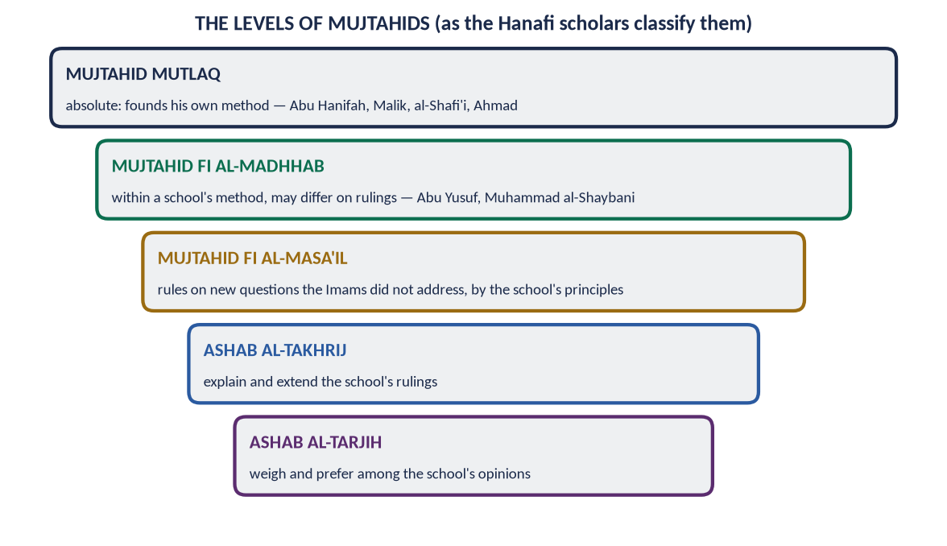
Figure 11 · The levels of mujtahids, as the Hanafi scholars classify them.

(2) By the number of people
- Individual Ijtihad (fardi) — a single jurist.
- Collective Ijtihad (jama'i) — a council of jurists and experts. It is the need of our age (the Fiqh Academy, the CII).

(3) By its method
- Bayani — interpreting texts (words, meanings).
- Qiyasi — analogy from a text through the 'illah.
- Istislahi — by public interest (maslahah) where there is no text.

(4) Full and partial
Most modern scholars hold that Ijtihad can be partial (tajzi'at al-ijtihad): one may be qualified in one field, such as finance, without mastering all of fiqh.

6.6 The principles of Ijtihad (2022)
- (1) No Ijtihad against a clear text — لَا اجْتِهَادَ مَعَ النَّصِّ ('no Ijtihad where there is a text'). It works in zanni texts and where there is no text.
- (2) Follow the order of sources — Quran → Sunnah → Ijma → Qiyas → secondary sources (Mu'adh's hadith).
- (3) Serve the Maqasid — protect faith, life, intellect, lineage and wealth.
- (4) Ease and removal of hardship — 'Allah intends ease for you' (Al-Baqarah 185); 'hardship brings ease' (المَشَقَّةُ تَجْلِبُ التَّيْسِيرَ).
- (5) Remove harm — 'no harm and no returning of harm' (Ibn Majah); 'harm is removed' (الضَّرَرُ يُزَالُ).
- (6) Necessity has limits — 'necessity makes the forbidden permissible' (Al-Baqarah 173), 'but only to the extent of the need'.
- (7) Consider custom and time — 'custom is authoritative'; 'the change of rulings with the change of times cannot be denied' (Majallah, Art. 39).
- (8) Consider consequences (ma'alat al-af'al) — al-Shatibi's principle: judge an act by where it leads.
- (9) Certainty is not removed by doubt — اليَقِينُ لَا يَزُولُ بِالشَّكِّ.
- (10) Humility — a mujtahid may be wrong. Imam al-Shafi'i: 'My view is right with the possibility of error; another's view is wrong with the possibility of being right.' Differences are a mercy, not a cause of enmity.

6.7 Was the 'gate of Ijtihad' closed?
From about the 4th century AH, many scholars held that the great schools had settled the main questions, and taqlid (following a school) became the norm. Historians call this the 'closing of the gate of Ijtihad'. In fact, Ijtihad never fully stopped: jurists kept issuing fatwas on new questions within their schools. Reformers from Shah Waliullah (d. 1762) to Iqbal called for its revival. Today the call for disciplined, collective Ijtihad is almost universal among scholars.

6.8 The contemporary importance of Ijtihad

(1) New questions that the classical books did not face
Field | Questions needing Ijtihad
Medicine and bioethics | Organ transplantation (the Fiqh Academy allowed it with conditions, 1988); blood donation; IVF within marriage; brain death; human cloning (forbidden by the Fiqh Academy, 1997)
Finance | Islamic banking, sukuk, takaful (cooperative insurance, approved by the Fiqh Academy, 1985), stock markets, digital currencies
Technology | Artificial intelligence, digital contracts, data privacy, cybercrime
Worship in new conditions | Prayer and fasting times in polar regions; moon-sighting and astronomical calculation; prayer on aircraft
Environment | Climate change, water, pollution — through the Maqasid (protecting life)
State and society | Constitutions, elections, human rights, citizenship of non-Muslims

(2) Keeping the Shari'ah alive and relevant
Without Ijtihad, Islamic law would be a museum. With it, the permanent principles meet changing needs. This is the permanence and flexibility of Chapter 1.

(3) Answering both extremes
It answers rigidity (refusing every new thing) and modernism without discipline (changing the religion to suit fashion). Qualified Ijtihad is the middle path.

(4) Islamising the law in Pakistan
The Council of Islamic Ideology and the Federal Shariat Court are forms of institutional Ijtihad. The riba judgements (1991, 1999, 2022) and the development of Islamic banking are its fruits.

(5) Unity of the Ummah
Collective Ijtihad through the OIC Fiqh Academy brings scholars of all schools together, reducing division.
✦ SCHOLARLY VIEW
Allama Muhammad Iqbal · The Reconstruction of Religious Thought in Islam, Lecture VI
“The principle of movement in the structure of Islam.”
➜ His definition of Ijtihad, and his call to exercise it through a Muslim legislative assembly guided by scholars.

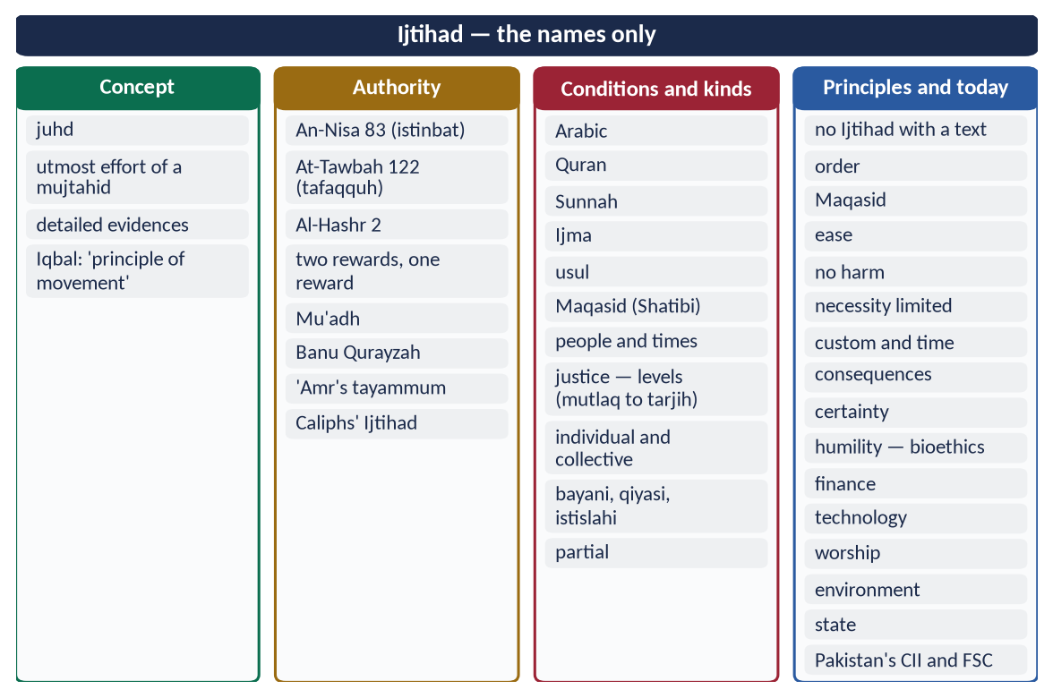
Figure 12 · At a glance — ijtihad — the names only. The detail is in the sections above.

Chapter 7 · The Social System of Islam
A syllabus line never asked, and so a strong likely question.

7.1 The foundations

(1) Tawhid and the unity of mankind
✦ QURAN
﴿يَـٰٓأَيُّهَا ٱلنَّاسُ ٱتَّقُواْ رَبَّكُمُ ٱلَّذِي خَلَقَكُم مِّن نَّفۡسٖ وَٰحِدَةٖ وَخَلَقَ مِنۡهَا زَوۡجَهَا وَبَثَّ مِنۡهُمَا رِجَالٗا كَثِيرٗا وَنِسَآءٗۚ …﴾
“O mankind, fear your Lord, who created you from one soul, created from it its mate, and spread from both of them many men and women.” (An-Nisa, Quran)
➜ O mankind, fear your Lord, who created you from a single soul, and created from it its mate, and spread from both many men and women.

(2) Equality and dignity
✦ QURAN
﴿يَـٰٓأَيُّهَا ٱلنَّاسُ إِنَّا خَلَقۡنَٰكُم مِّن ذَكَرٖ وَأُنثَىٰ وَجَعَلۡنَٰكُمۡ شُعُوبٗا وَقَبَآئِلَ لِتَعَارَفُوٓاْۚ إِنَّ أَكۡرَمَكُمۡ عِندَ ٱللَّهِ أَتۡقَىٰكُمۡۚ إِنَّ ٱللَّهَ عَلِيمٌ خَبِيرٞ﴾
“O mankind, indeed We have created you from male and female and made you peoples and tribes that you may know one another. Indeed, the most noble of you in the sight of Allah is the most righteous of you. Indeed, Allah is Knowing and Acquainted.” (Al-Hujurat, Quran)
➜ O mankind, We created you from a male and a female and made you peoples and tribes so that you may know one another. The most noble of you with Allah is the most righteous.

✦ QURAN
﴿وَلَقَدۡ كَرَّمۡنَا بَنِيٓ ءَادَمَ وَحَمَلۡنَٰهُمۡ فِي ٱلۡبَرِّ وَٱلۡبَحۡرِ وَرَزَقۡنَٰهُم مِّنَ ٱلطَّيِّبَٰتِ وَفَضَّلۡنَٰهُمۡ عَلَىٰ كَثِيرٖ مِّمَّنۡ خَلَقۡنَا تَفۡضِيلٗا﴾
“And We have certainly honored the children of Adam and carried them on the land and sea and provided for them of the good things and preferred them over much of what We have created, with [definite] preference.” (Al-Isra, Quran)
➜ 'We have honoured the children of Adam.'

✦ FROM THE SIRAH
لَا فَضْلَ لِعَرَبِيٍّ عَلَى عَجَمِيٍّ، وَلَا لِعَجَمِيٍّ عَلَى عَرَبِيٍّ، وَلَا لِأَحْمَرَ عَلَى أَسْوَدَ، وَلَا أَسْوَدَ عَلَى أَحْمَرَ، إِلَّا بِالتَّقْوَى
“No Arab is superior to a non-Arab, nor a non-Arab to an Arab, nor a white to a black, nor a black to a white — except by righteousness.” (Musnad Ahmad (Farewell Sermon))

(3) Brotherhood
✦ QURAN
﴿إِنَّمَا ٱلۡمُؤۡمِنُونَ إِخۡوَةٞ فَأَصۡلِحُواْ بَيۡنَ أَخَوَيۡكُمۡۚ وَٱتَّقُواْ ٱللَّهَ لَعَلَّكُمۡ تُرۡحَمُونَ﴾
“The believers are but brothers, so make settlement between your brothers. And fear Allah that you may receive mercy.” (Al-Hujurat, Quran)
➜ 'The believers are but brothers, so make peace between your brothers.'

The Mu'akhat (622) paired Muhajirun with Ansar and shared homes and wealth.

7.2 The salient features of the social system

(1) The family — the first unit of society
✦ QURAN
﴿وَمِنۡ ءَايَٰتِهِۦٓ أَنۡ خَلَقَ لَكُم مِّنۡ أَنفُسِكُمۡ أَزۡوَٰجٗا لِّتَسۡكُنُوٓاْ إِلَيۡهَا وَجَعَلَ بَيۡنَكُم مَّوَدَّةٗ وَرَحۡمَةًۚ إِنَّ فِي ذَٰلِكَ لَأٓيَٰتٖ لِّقَوۡمٖ يَتَفَكَّرُونَ﴾
“And of His signs is that He created for you from yourselves mates that you may find tranquillity in them; and He placed between you affection and mercy. Indeed in that are signs for a people who give thought.” (Ar-Rum, Quran)
➜ He created for you mates from among yourselves that you may find tranquillity in them, and He placed between you affection and mercy.

Marriage is a contract with rights on both sides; parents are to be honoured (Al-Isra 23–24); children are to be raised and educated; the extended family is served through silat al-rahm (ties of kinship).

(2) Rights of relatives, neighbours and the weak
✦ QURAN
﴿وَٱعۡبُدُواْ ٱللَّهَ وَلَا تُشۡرِكُواْ بِهِۦ شَيۡـٔٗاۖ وَبِٱلۡوَٰلِدَيۡنِ إِحۡسَٰنٗا وَبِذِي ٱلۡقُرۡبَىٰ وَٱلۡيَتَٰمَىٰ وَٱلۡمَسَٰكِينِ وَٱلۡجَارِ ذِي ٱلۡقُرۡبَىٰ وَٱلۡجَارِ ٱلۡجُنُبِ وَٱلصَّاحِبِ بِٱلۡجَنۢبِ وَٱبۡنِ ٱلسَّبِيلِ …﴾
“Worship Allah and associate nothing with Him, and do good to parents, relatives, orphans, the needy, the near neighbour, the distant neighbour, the companion at your side and the traveller.” (An-Nisa, Quran)
➜ Worship Allah … and do good to parents, relatives, orphans, the needy, the near neighbour, the distant neighbour, the companion at your side, the traveller.

✦ HADITH
مَا زَالَ جِبْرِيلُ يُوصِينِي بِالْجَارِ حَتَّى ظَنَنْتُ أَنَّهُ سَيُوَرِّثُهُ
“Jibril kept urging me to be good to the neighbour until I thought he would make him an heir.” (Al-Bukhari and Muslim)

(3) The status of women
Equal in faith and reward (Al-Ahzab 35); rights of property, inheritance, education, consent in marriage and mahr (Topic 4).

(4) Social justice and welfare
Zakat, sadaqah and the Bayt al-Mal ensure that no one is abandoned.
✦ HADITH
مَثَلُ الْمُؤْمِنِينَ فِي تَوَادِّهِمْ وَتَرَاحُمِهِمْ وَتَعَاطُفِهِمْ مَثَلُ الْجَسَدِ
“The believers in their love, mercy and compassion are like one body.” (Al-Bukhari and Muslim)
➜ When one limb aches, the whole body responds.

(5) Enjoining good and forbidding evil
✦ QURAN
﴿كُنتُمۡ خَيۡرَ أُمَّةٍ أُخۡرِجَتۡ لِلنَّاسِ تَأۡمُرُونَ بِٱلۡمَعۡرُوفِ وَتَنۡهَوۡنَ عَنِ ٱلۡمُنكَرِ وَتُؤۡمِنُونَ بِٱللَّهِۗ …﴾
“You are the best nation brought forth for mankind: you enjoin what is right, forbid what is wrong, and believe in Allah.” (Aal-e-Imran, Quran)
➜ You are the best nation raised for mankind: you enjoin right and forbid wrong.

(6) Modesty and purity
✦ QURAN
﴿قُل لِّلۡمُؤۡمِنِينَ يَغُضُّواْ مِنۡ أَبۡصَٰرِهِمۡ وَيَحۡفَظُواْ فُرُوجَهُمۡۚ …﴾
“Tell the believing men to lower their gaze and guard their modesty …” (An-Nur, Quran)
➜ Modesty for both men and women protects the family.

(7) Ban on social evils
Alcohol and gambling (Al-Ma'idah 90); adultery (Al-Isra 32); backbiting, spying and suspicion (Al-Hujurat 12); mockery and name-calling (Al-Hujurat 11).

(8) Knowledge and education
'Read!' (Al-Alaq 1); 'Seeking knowledge is an obligation on every Muslim' (Ibn Majah).

(9) Tolerance and rights of non-Muslims
'No compulsion in religion' (Al-Baqarah 256); the Charter of Madinah; the covenants of the Caliphs (Topic 5).

(10) Etiquette of social life
Greeting with salam, visiting the sick, attending funerals, keeping promises, honouring guests: 'Whoever believes in Allah and the Last Day, let him honour his guest' (Al-Bukhari and Muslim).

(11) Institutions of social life
- The mosque — worship, education, consultation and welfare in one place, as in the Prophet's Mosque.
- The waqf — endowments for schools, hospitals, wells and inns.
- Mu'akhat and neighbourhood — care networks that reach every home.

(12) Social security for the weak
✦ QURAN
﴿فَأَمَّا ٱلۡيَتِيمَ فَلَا تَقۡهَرۡ ۝ وَأَمَّا ٱلسَّآئِلَ فَلَا تَنۡهَرۡ﴾
“So as for the orphan, do not oppress [him]. And as for the petitioner, do not repel [him].” (Ad-Duha, Quran)
➜ 'As for the orphan, do not oppress him; and as for the one who asks, do not repel him.'

✦ HADITH
أَنَا وَكَافِلُ الْيَتِيمِ فِي الْجَنَّةِ هَكَذَا
“I and the one who cares for an orphan will be in Paradise like this — and he held up two fingers together.” (Al-Bukhari)

7.2a The Islamic and the Western social systems compared
Point | Modern Western social order | Islamic social order
Basis | Individual freedom and rights | Tawhid; rights with duties
Unit of society | The individual | The family
Relations of the sexes | Personal choice | Marriage; modesty for both sexes
Care of the old | Often institutional | Duty of children (Al-Isra 23–24)
Welfare | The state's social security | State + Zakat + family + neighbours + waqf
Morality | Largely private | Public and private, guided by revelation

7.3 Relevance to modern society
Modern problem | The Islamic social answer
Breakdown of the family; loneliness of the old | Marriage as mercy; honouring parents; silat al-rahm
Racism and class pride | Al-Hujurat 13; the Farewell Sermon
Individualism, no care for neighbours | Rights of neighbours; 'one body'
Addiction, crime | Ban on intoxicants; moral education
Sexual exploitation | Modesty for both sexes; marriage made easy
Poverty amid plenty | Zakat, sadaqah, social security

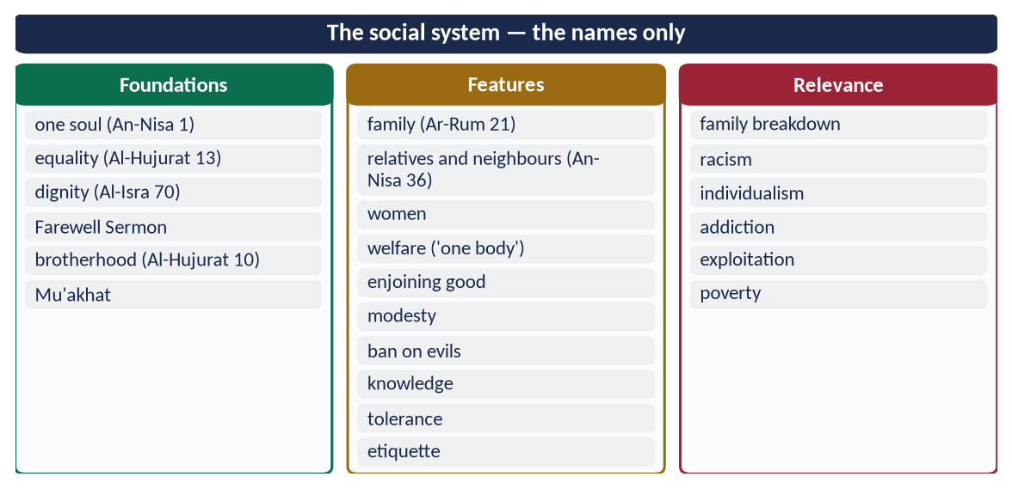
Figure 13 · At a glance — the social system — the names only. The detail is in the sections above.

Chapter 8 · The Political System of Islam
Taught in detail in Topic 8. Here, its salient features as part of the Islamic code of life.

8.1 The salient features
- (1) Sovereignty of Allah: 'The judgement is only for Allah' (Yusuf 40).
- (2) Khilafah — authority as a trust: 'I am placing on earth a khalifah' (Al-Baqarah 30); 'render trusts to those entitled' (An-Nisa 58).
- (3) The Prophet ﷺ as the model: the state of Madinah and its Charter (622).
- (4) Shura: 'their affairs are by consultation' (Ash-Shura 38).
- (5) Selection by consent (bay'ah) and merit: the four Rightly-Guided Caliphs; no heredity.
- (6) Rule of law and equality: 'If Fatimah stole …' (Al-Bukhari and Muslim).
- (7) Justice: An-Nisa 135; Al-Ma'idah 8.
- (8) Accountability: 'If I do wrong, set me right' (Abu Bakr).
- (9) Fundamental rights: life, property, honour, belief, expression.
- (10) Rights of non-Muslim citizens: the Charter of Madinah; the covenant of Jerusalem (638).
- (11) Welfare state: Al-Hajj 41; Umar's Diwan.
- (12) Conditional obedience: 'No obedience in disobedience' (Al-Bukhari and Muslim).

8.1a The aims of the Islamic state
✦ QURAN
﴿ٱلَّذِينَ إِن مَّكَّنَّـٰهُمۡ فِي ٱلۡأَرۡضِ أَقَامُواْ ٱلصَّلَوٰةَ وَءَاتَوُاْ ٱلزَّكَوٰةَ وَأَمَرُواْ بِٱلۡمَعۡرُوفِ وَنَهَوۡاْ عَنِ ٱلۡمُنكَرِۗ وَلِلَّهِ عَٰقِبَةُ ٱلۡأُمُورِ﴾
“[And they are] those who, if We give them authority in the land, establish prayer and give zakah and enjoin what is right and forbid what is wrong. And to Allah belongs the outcome of [all] matters.” (Al-Hajj, Quran)
➜ Those who, if We establish them in the land, establish prayer, give zakat, enjoin good and forbid evil.

✦ QURAN
﴿لَقَدۡ أَرۡسَلۡنَا رُسُلَنَا بِٱلۡبَيِّنَٰتِ وَأَنزَلۡنَا مَعَهُمُ ٱلۡكِتَٰبَ وَٱلۡمِيزَانَ لِيَقُومَ ٱلنَّاسُ بِٱلۡقِسۡطِۖ …﴾
“We sent Our messengers with clear proofs and sent down with them the Book and the Balance, so that people may uphold justice.” (Al-Hadid, Quran)
➜ We sent Our messengers … so that people may uphold justice.

- Establishing justice and the rule of law.
- Protecting the Maqasid: the faith, life, intellect, lineage and property of all citizens.
- Welfare: basic needs for every citizen, as Umar's Diwan provided.
- Security: defence of the borders and order within.
- Enjoining good: education, moral life, Hisbah.

8.1b The rights of citizens
Right | Evidence
Life and security | 'Your blood, your property and your honour are sacred' (Farewell Sermon; Al-Bukhari)
Property | An-Nisa 29; theft punished
Honour and privacy | Al-Hujurat 11–12: no mockery, no spying
Belief | Al-Baqarah 256: no compulsion
Expression and criticism | 'Set me right'; 'a word of justice'; Umar's 'Fear Allah' accepted
Justice and a fair trial | 'Hear the other'; 'proof on the claimant'
Equality | Al-Hujurat 13; the Fatimah hadith
Basic needs | Umar's stipends; the Bayt al-Mal
Participation | Shura; bay'ah

8.1c The duties of citizens
- Obedience to lawful authority within the law (An-Nisa 59).
- Sincere advice (nasihah) to rulers (Muslim).
- Defence of the state when called.
- Payment of Zakat and lawful taxes.
- Honesty and respect for public property.
- Participation in consultation and in the common good.

8.2 In Pakistan
The Objectives Resolution (1949), made part of the Constitution as Article 2A: 'Sovereignty over the entire Universe belongs to Almighty Allah alone, and the authority to be exercised by the people of Pakistan within the limits prescribed by Him is a sacred trust.'
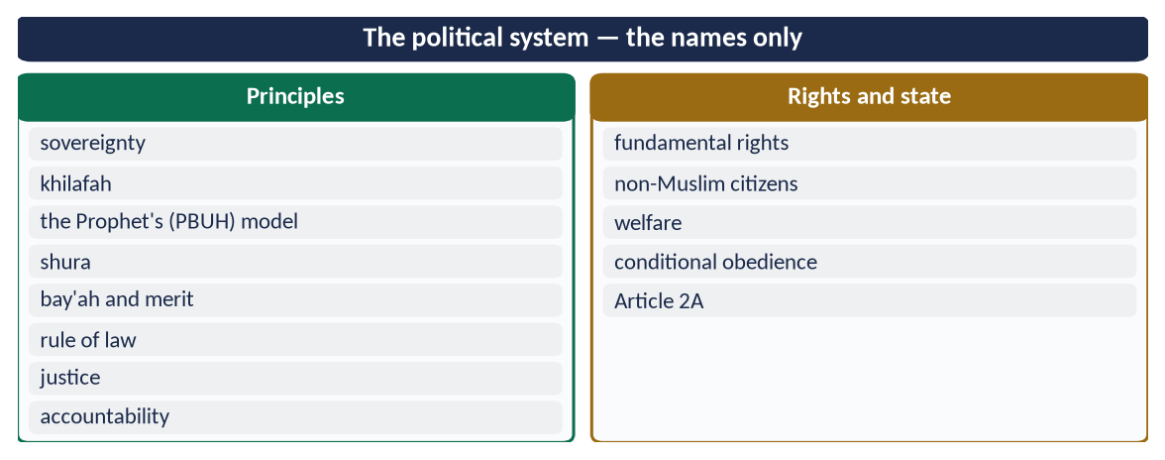
Figure 14 · At a glance — the political system — the names only. The detail is in the sections above.

Chapter 9 · The Economic System of Islam
Asked in 2020 ('"Islamic Financial and Economic system is the solution of the human financial problems". Discuss.') and 2022 ('Write down the main principles of Islamic Economics. How do these principles provide solutions to contemporary challenges?').

9.1 The nature of Islamic economics
Islamic economics is the study and organisation of economic life within the Shari'ah, to achieve falah (success in both worlds) through justice, growth and the satisfaction of everyone's basic needs. It differs from both modern systems:
Point | Capitalism | Socialism | Islam
Ownership | Private, almost unlimited | State | Allah's; man a trustee — private, public and state ownership, each within limits
Motive | Profit | Collective plan | Profit with morality and the Hereafter
Interest | The heart of finance | Used by the state | Forbidden
Distribution | By the market | By the state | Market + Zakat, inheritance, welfare
Freedom | Maximum | Minimum | Freedom within halal and haram
Result | Growth with inequality | Equality with poor growth | Growth with justice

9.2 The main principles of Islamic economics (2022)
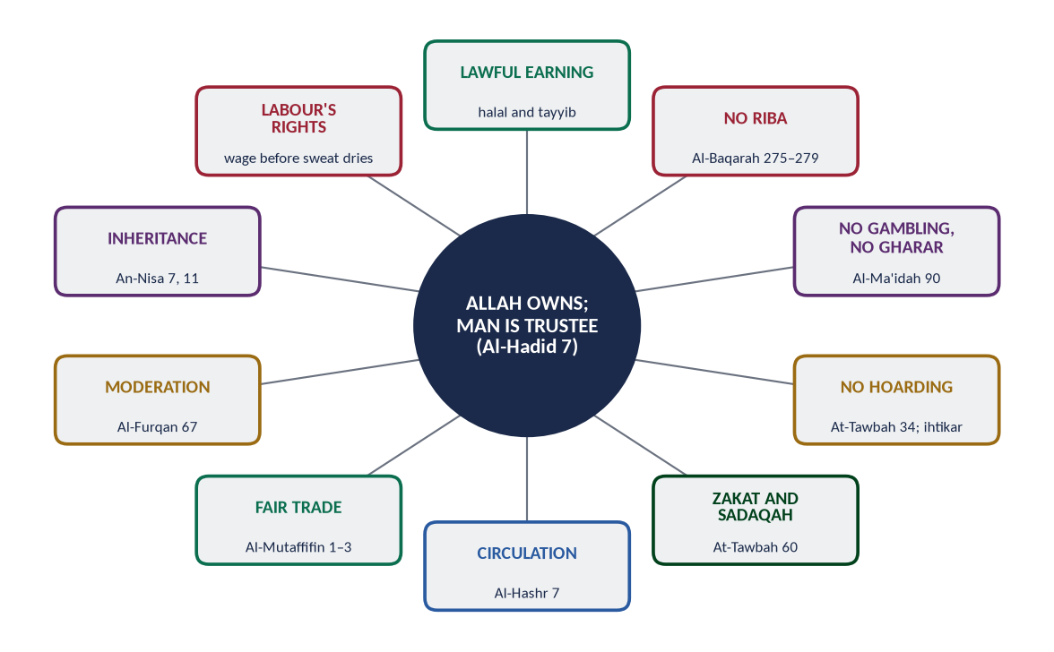
Figure 15 · The principles of the Islamic economic system.

(1) Allah is the owner; man is a trustee
✦ QURAN
﴿ءَامِنُواْ بِٱللَّهِ وَرَسُولِهِۦ وَأَنفِقُواْ مِمَّا جَعَلَكُم مُّسۡتَخۡلَفِينَ فِيهِۖ فَٱلَّذِينَ ءَامَنُواْ مِنكُمۡ وَأَنفَقُواْ لَهُمۡ أَجۡرٞ كَبِيرٞ﴾
“Believe in Allah and His Messenger and spend out of that in which He has made you successors. For those who have believed among you and spent, there will be a great reward.” (Al-Hadid, Quran)
➜ Believe in Allah and His Messenger and spend of that in which He has made you trustees (mustakhlafin).

✦ QURAN
﴿… وَءَاتُوهُم مِّن مَّالِ ٱللَّهِ ٱلَّذِيٓ ءَاتَىٰكُمۡۚ …﴾
“And give them from the wealth of Allah which He has given you.” (An-Nur, Quran)
➜ 'Give them from the wealth of Allah which He has given you.'

(2) Right to private property, within limits
✦ QURAN
﴿… لَا تَأۡكُلُوٓاْ أَمۡوَٰلَكُم بَيۡنَكُم بِٱلۡبَٰطِلِ إِلَّآ أَن تَكُونَ تِجَٰرَةً عَن تَرَاضٖ مِّنكُمۡۚ …﴾
“Do not consume one another's wealth unjustly, but only in lawful trade by mutual consent.” (An-Nisa, Quran)
➜ Do not consume one another's wealth unjustly, but only by trade with mutual consent.

Property is protected (theft is punished, Al-Ma'idah 38), but it carries duties: Zakat and the rights of others.

(3) Lawful and good earning (halal and tayyib)
✦ QURAN
﴿يَـٰٓأَيُّهَا ٱلنَّاسُ كُلُواْ مِمَّا فِي ٱلۡأَرۡضِ حَلَٰلٗا طَيِّبٗا وَلَا تَتَّبِعُواْ خُطُوَٰتِ ٱلشَّيۡطَٰنِۚ إِنَّهُۥ لَكُمۡ عَدُوّٞ مُّبِينٌ﴾
“O mankind, eat from whatever is on earth [that is] lawful and good and do not follow the footsteps of Satan. Indeed, he is to you a clear enemy.” (Al-Baqarah, Quran)
➜ O mankind, eat of what is lawful and good on the earth.

✦ HADITH
مَا أَكَلَ أَحَدٌ طَعَامًا قَطُّ خَيْرًا مِنْ أَنْ يَأْكُلَ مِنْ عَمَلِ يَدِهِ
“No one has ever eaten better food than what he eats from the work of his own hands.” (Al-Bukhari)

(4) Prohibition of riba (interest)
✦ QURAN
﴿… وَأَحَلَّ ٱللَّهُ ٱلۡبَيۡعَ وَحَرَّمَ ٱلرِّبَوٰاْۚ …﴾
“Allah has permitted trade and has forbidden riba.” (Al-Baqarah, Quran)

✦ QURAN
﴿… وَذَرُواْ مَا بَقِيَ مِنَ ٱلرِّبَوٰٓاْ إِن كُنتُم مُّؤۡمِنِينَ ۝ فَإِن لَّمۡ تَفۡعَلُواْ فَأۡذَنُواْ بِحَرۡبٖ مِّنَ ٱللَّهِ وَرَسُولِهِۦۖ وَإِن تُبۡتُمۡ فَلَكُمۡ رُءُوسُ أَمۡوَٰلِكُمۡ لَا تَظۡلِمُونَ وَلَا تُظۡلَمُونَ﴾
“… and give up what remains of riba, if you are believers. If you do not, then be informed of a war from Allah and His Messenger. But if you repent, you may have your principal — do no wrong and suffer no wrong.” (Al-Baqarah, Quran)
➜ O you who believe, fear Allah and give up what remains of riba … If you do not, then be informed of a war from Allah and His Messenger. But if you repent, you may have your principal — do no wrong and suffer no wrong.

✦ HADITH
لَعَنَ رَسُولُ اللَّهِ ﷺ آكِلَ الرِّبَا، وَمُؤْكِلَهُ، وَكَاتِبَهُ، وَشَاهِدَيْهِ، وَقَالَ: هُمْ سَوَاءٌ
“The Messenger of Allah ﷺ cursed the one who consumes riba, the one who pays it, the one who writes it and its two witnesses, and said: they are all equal.” (Muslim)

(5) Prohibition of gambling (maysir) and excessive uncertainty (gharar)
✦ QURAN
﴿يَـٰٓأَيُّهَا ٱلَّذِينَ ءَامَنُوٓاْ إِنَّمَا ٱلۡخَمۡرُ وَٱلۡمَيۡسِرُ وَٱلۡأَنصَابُ وَٱلۡأَزۡلَٰمُ رِجۡسٞ مِّنۡ عَمَلِ ٱلشَّيۡطَٰنِ فَٱجۡتَنِبُوهُ لَعَلَّكُمۡ تُفۡلِحُونَ﴾
“O you who have believed, indeed, intoxicants, gambling, [sacrificing on] stone alters [to other than Allah], and divining arrows are but defilement from the work of Satan, so avoid it that you may be successful.” (Al-Ma'idah, Quran)
➜ Intoxicants, gambling, idols and divining arrows are filth from the work of Shaytan, so avoid them.

The Prophet ﷺ forbade the sale of gharar (Muslim) — the sale of fish in the water, of birds in the air, of what is not yet owned.

(6) Prohibition of hoarding
✦ QURAN
﴿… وَٱلَّذِينَ يَكۡنِزُونَ ٱلذَّهَبَ وَٱلۡفِضَّةَ وَلَا يُنفِقُونَهَا فِي سَبِيلِ ٱللَّهِ فَبَشِّرۡهُم بِعَذَابٍ أَلِيمٖ﴾
“And those who hoard gold and silver and do not spend it in the way of Allah — give them tidings of a painful punishment.” (At-Tawbah, Quran)
➜ Those who hoard gold and silver and do not spend it in the way of Allah — give them news of a painful punishment.

✦ HADITH
لَا يَحْتَكِرُ إِلَّا خَاطِئٌ
“None hoards (goods to raise prices) except a sinner.” (Muslim)

(7) Zakat and spending
✦ QURAN
﴿إِنَّمَا ٱلصَّدَقَٰتُ لِلۡفُقَرَآءِ وَٱلۡمَسَٰكِينِ وَٱلۡعَٰمِلِينَ عَلَيۡهَا وَٱلۡمُؤَلَّفَةِ قُلُوبُهُمۡ وَفِي ٱلرِّقَابِ وَٱلۡغَٰرِمِينَ وَفِي سَبِيلِ ٱللَّهِ وَٱبۡنِ ٱلسَّبِيلِۖ فَرِيضَةٗ مِّنَ ٱللَّهِۗ وَٱللَّهُ عَلِيمٌ حَكِيمٞ﴾
“Zakah expenditures are only for the poor and for the needy and for those employed to collect [zakah] and for bringing hearts together [for Islam] and for freeing captives [or slaves] and for those in debt and for the cause of Allah and for the [stranded] traveler - an obligation [imposed] by Allah. And Allah is Knowing and Wise.” (At-Tawbah, Quran)
➜ Zakat is only for the poor, the needy, those employed to collect it, those whose hearts are to be reconciled, freeing captives, debtors, in the way of Allah and the traveller.

The Zakat rates:
- 2.5% on savings and trade goods above the nisab;
- 5% or 10% (Ushr) on crops;
- 20% on buried treasure.

(8) Circulation of wealth
✦ QURAN
﴿… كَيۡ لَا يَكُونَ دُولَةَۢ بَيۡنَ ٱلۡأَغۡنِيَآءِ مِنكُمۡۚ …﴾
“… so that it does not circulate only among the rich among you.” (Al-Hashr, Quran)
➜ So that it does not circulate only among the rich among you.

(9) Fair dealing in trade
✦ QURAN
﴿وَيۡلٞ لِّلۡمُطَفِّفِينَ ۝ ٱلَّذِينَ إِذَا ٱكۡتَالُواْ عَلَى ٱلنَّاسِ يَسۡتَوۡفُونَ ۝ وَإِذَا كَالُوهُمۡ أَو وَّزَنُوهُمۡ يُخۡسِرُونَ﴾
“Woe to those who give less [than due]. Who, when they take a measure from people, take in full. But if they give by measure or by weight to them, they cause loss.” (Al-Mutaffifin, Quran)
➜ Woe to those who give less, who take full measure from people but give less when they measure for them.

✦ HADITH
التَّاجِرُ الصَّدُوقُ الْأَمِينُ مَعَ النَّبِيِّينَ وَالصِّدِّيقِينَ وَالشُّهَدَاءِ
“The truthful, trustworthy merchant will be with the prophets, the truthful and the martyrs.” (Al-Tirmidhi)

(10) Moderation — neither miserliness nor waste
✦ QURAN
﴿وَٱلَّذِينَ إِذَآ أَنفَقُواْ لَمۡ يُسۡرِفُواْ وَلَمۡ يَقۡتُرُواْ وَكَانَ بَيۡنَ ذَٰلِكَ قَوَامٗا﴾
“And [they are] those who, when they spend, do so not excessively or sparingly but are ever, between that, [justly] moderate.” (Al-Furqan, Quran)
➜ Those who, when they spend, are neither extravagant nor miserly, but hold a just balance between them.

✦ QURAN
﴿إِنَّ ٱلۡمُبَذِّرِينَ كَانُوٓاْ إِخۡوَٰنَ ٱلشَّيَٰطِينِۖ وَكَانَ ٱلشَّيۡطَٰنُ لِرَبِّهِۦ كَفُورٗا﴾
“Indeed, the wasteful are brothers of the devils, and ever has Satan been to his Lord ungrateful.” (Al-Isra, Quran)
➜ 'The wasteful are brothers of the devils.'

(11) Rights of labour
✦ HADITH
أَعْطُوا الْأَجِيرَ أَجْرَهُ قَبْلَ أَنْ يَجِفَّ عَرَقُهُ
“Give the worker his wage before his sweat dries.” (Ibn Majah)

'Your servants are your brothers … do not burden them beyond their capacity' (Al-Bukhari).

(12) Inheritance — wealth divided at every death
✦ QURAN
﴿لِّلرِّجَالِ نَصِيبٞ مِّمَّا تَرَكَ ٱلۡوَٰلِدَانِ وَٱلۡأَقۡرَبُونَ وَلِلنِّسَآءِ نَصِيبٞ مِّمَّا تَرَكَ ٱلۡوَٰلِدَانِ وَٱلۡأَقۡرَبُونَ مِمَّا قَلَّ مِنۡهُ أَوۡ كَثُرَۚ نَصِيبٗا مَّفۡرُوضٗا﴾
“For men is a share of what the parents and close relatives leave, and for women is a share of what the parents and close relatives leave, be it little or much - an obligatory share.” (An-Nisa, Quran)
➜ For men is a share of what parents and relatives leave, and for women is a share … whether little or much.

(13) Social security — the state's duty
The Bayt al-Mal guaranteed basic needs: Umar's stipends even for new-born children and for poor non-Muslims.

(14) Contracts and documentation
✦ QURAN
﴿يَـٰٓأَيُّهَا ٱلَّذِينَ ءَامَنُوٓاْ أَوۡفُواْ بِٱلۡعُقُودِۚ …﴾
“O you who have believed, fulfil the contracts.” (Al-Ma'idah, Quran)
➜ 'Fulfil your contracts.'

9.3 The instruments of Islamic finance
Instrument | Meaning
Mudarabah | Partnership: one gives capital, the other labour; profit shared by agreement, loss borne by the capital
Musharakah | Joint venture: all give capital; profit by agreement, loss by capital share
Murabahah | Cost-plus sale: the bank buys and sells at a known profit
Ijarah | Leasing
Salam and Istisna' | Advance purchase of crops; manufacturing contract
Sukuk | Islamic certificates backed by real assets (Pakistan's sovereign sukuk since 2008)
Takaful | Cooperative insurance
Qard hasan | Interest-free loan (e.g. Akhuwat, Pakistan, founded 2001)
Waqf | Endowment for permanent public benefit

9.4 How the principles solve contemporary challenges (2020, 2022)
Challenge | Islamic solution
Poverty | Zakat and Ushr, sadaqah, waqf, the state's duty of basic needs
Inequality | Circulation (Al-Hashr 7), inheritance, ban on hoarding and riba (Chapter 10)
Debt crises | Ban on riba; risk-sharing instead of debt; qard hasan
Financial crises (2008) | Finance tied to real assets; no gharar, no speculation on debt; after 2008 even a Vatican newspaper (2009) suggested banks look at the ethics of Islamic finance
Inflation and speculation | Ban on hoarding and gharar; sound money (Umar's standard coins)
Unemployment | Mudarabah and musharakah finance enterprise; dignity of labour
Corruption | Ghulul and bribery forbidden; accountability
Exploitation of workers | Fair wage 'before the sweat dries'
Consumerism and waste | Moderation (Al-Furqan 67; Al-A'raf 31)
Environmental damage | Man as trustee; 'do not spread corruption on earth' (Al-A'raf 56)

9.4a The economic effects of Zakat
- Redistribution — every year a share of wealth moves from the rich to the poor.
- Investment — idle money loses 2.5% a year, so owners invest it in trade and industry.
- Demand — the poor spend what they receive, which raises demand and employment.
- Social security — a permanent fund for the poor, debtors and travellers, without interest.
- Social peace — it removes envy and builds brotherhood.
✦ QURAN
﴿خُذۡ مِنۡ أَمۡوَٰلِهِمۡ صَدَقَةٗ تُطَهِّرُهُمۡ وَتُزَكِّيهِم بِهَا …﴾
“Take from their wealth a charity by which you purify them and cause them to grow.” (At-Tawbah, Quran)
➜ 'Take from their wealth a charity by which you purify them and cause them to grow.'

9.4b Pakistan's economic challenges and Islamic answers
Pakistan's challenge | Islamic answer
Public debt and interest payments that take much of the federal budget | Risk-sharing finance; sukuk; ending riba (Chapter 10)
A narrow tax base; elite exemptions | Zakat on the rich; justice in taxation (Ali's 'the land before the tax')
Inflation | No hoarding; sound money; honest markets
Unemployment among the young | Mudarabah, musharakah, qard hasan for small enterprise
Informal economy and corruption | Fair trade; documentation (Al-Baqarah 282); accountability

9.5 Is the Islamic system 'the solution'? A balanced view (2020)
- Yes, in principle: it joins efficiency with justice, markets with morality, and property with duty.
- Evidence of practice:
- the welfare of the Caliphate — under Umar ibn Abd al-Aziz, reports say Zakat collectors found no one poor enough to take it in some regions;
- global Islamic finance assets have grown to over 4 trillion dollars (industry estimates, 2023);
- Islamic banking in Pakistan is now about a quarter of banking assets.
- But the conditions matter. Islamic finance that only copies conventional products ('interest by another name') loses the spirit. The solution needs:
- real profit-and-loss sharing;
- honest Zakat;
- good governance;
- education.
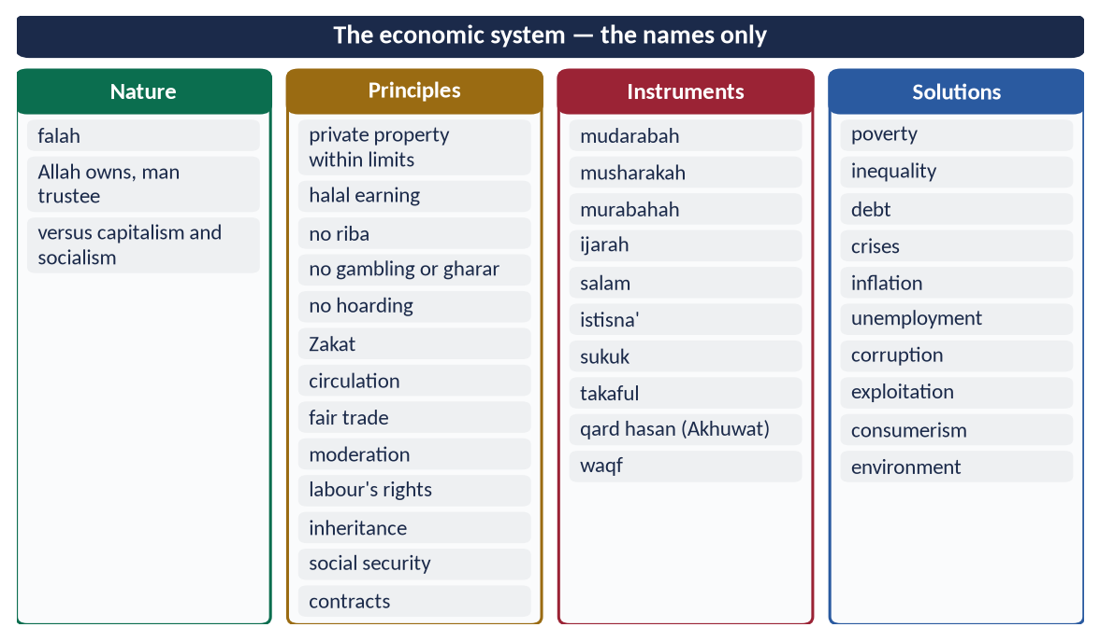
Figure 16 · At a glance — the economic system — the names only. The detail is in the sections above.

Chapter 10 · Concentration of Wealth and Riba
The subject of 2025: 'What are the disadvantages of concentration of wealth? What economic measures has Islam introduced to prevent this concentration of wealth?'

10.1 The problem today
The World Inequality Report 2022 found that the richest 10% own about three-quarters of global wealth, while the poorer half own about 2%. In Pakistan, the UNDP's National Human Development Report (2020) estimated the privileges enjoyed by the country's elite groups at about 17.4 billion dollars a year, roughly 6% of GDP.

10.2 The disadvantages of concentration of wealth

(1) Poverty amid plenty
When wealth is locked in a few hands, the many lack food, health and education.

(2) Class hatred and social unrest
Envy, crime and revolutions — history's great upheavals often followed extreme inequality.

(3) Economic slowdown
The poor cannot buy, demand falls, and businesses close. Hoarded wealth does not work for society.

(4) Monopoly and exploitation
The rich control markets, prices and wages.

(5) Political capture
Wealth buys influence: laws, taxes and contracts favour the few. Democracy becomes plutocracy.

(6) Moral decay — the Qarun syndrome
✦ QURAN
﴿إِنَّ قَٰرُونَ كَانَ مِن قَوۡمِ مُوسَىٰ فَبَغَىٰ عَلَيۡهِمۡۖ …﴾
“Indeed, Qarun was from the people of Musa, but he tyrannised over them.” (Al-Qasas, Quran)
➜ Wealth bred arrogance: 'I was only given it because of knowledge I have' (Al-Qasas 78). The earth swallowed him and his house (Al-Qasas 81).

✦ QURAN
﴿كَلَّآ إِنَّ ٱلۡإِنسَٰنَ لَيَطۡغَىٰٓ ۝ أَن رَّءَاهُ ٱسۡتَغۡنَىٰٓ﴾
“No! [But] indeed, man transgresses. Because he sees himself self-sufficient.” (Al-Alaq, Quran)
➜ No! Indeed, man transgresses because he sees himself self-sufficient.

(7) Weakness of the Ummah
A nation divided between the super-rich and the destitute cannot be strong or united.
✦ QURAN
﴿… كَيۡ لَا يَكُونَ دُولَةَۢ بَيۡنَ ٱلۡأَغۡنِيَآءِ مِنكُمۡۚ …﴾
“… so that it does not circulate only among the rich among you.” (Al-Hashr, Quran)
➜ So that it does not circulate only among the rich among you.

10.3 The measures Islam introduced to prevent concentration
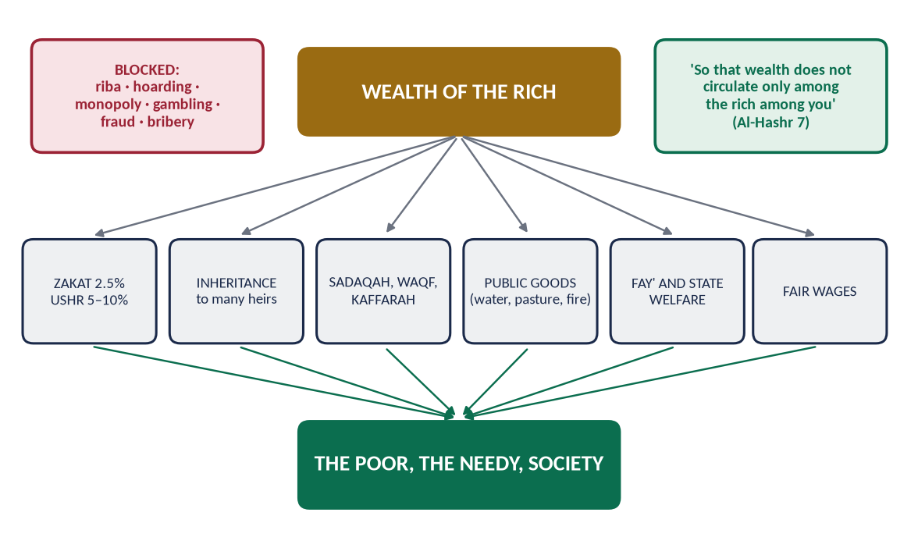
Figure 17 · How Islam moves wealth from the few to the many.

(1) Zakat — a yearly transfer
2.5% of accumulated wealth every year, and 5–10% of produce, to eight categories (At-Tawbah 60). Wealth that sits idle is slowly eaten by Zakat, so it is pushed into investment.
✦ HADITH
تُؤْخَذُ مِنْ أَغْنِيَائِهِمْ فَتُرَدُّ عَلَى فُقَرَائِهِمْ
“It is taken from their rich and returned to their poor.” (Al-Bukhari and Muslim)
➜ The Prophet's ﷺ instruction to Mu'adh when he sent him to Yemen.

(2) The law of inheritance
At every death, wealth is divided among many heirs, men and women (An-Nisa 7, 11, 12, 176). Bequests are limited to one-third: 'A third, and a third is a lot' (Al-Bukhari and Muslim), and cannot favour an heir. No primogeniture: big estates cannot pass whole to one son.

(3) Prohibition of riba
Interest transfers wealth from the borrower (who works) to the lender (who waits), and from the poor to the rich. Islam replaces it with profit-and-loss sharing.

(4) Prohibition of hoarding (kanz and ihtikar)
At-Tawbah 34–35: hoarded gold and silver will be heated and used to brand their owners. 'None hoards except a sinner' (Muslim).

(5) Voluntary spending (infaq and sadaqah)
✦ QURAN
﴿… وَيَسۡـَٔلُونَكَ مَاذَا يُنفِقُونَۖ قُلِ ٱلۡعَفۡوَۗ …﴾
“They ask you what they should spend. Say: 'The surplus (al-'afw).'” (Al-Baqarah, Quran)

✦ QURAN
﴿وَفِيٓ أَمۡوَٰلِهِمۡ حَقّٞ لِّلسَّآئِلِ وَٱلۡمَحۡرُومِ﴾
“And from their properties was [given] the right of the [needy] petitioner and the deprived.” (Adh-Dhariyat, Quran)
➜ In their wealth was a right for the one who asks and the deprived.

(6) Waqf — permanent charity
When Umar (RA) received land at Khaybar, the Prophet ﷺ told him: 'If you wish, keep the asset itself and give its produce in charity' (Al-Bukhari and Muslim) — the origin of waqf. Waqfs funded schools, hospitals, wells and inns across Muslim history.

(7) Public ownership of essential resources
✦ HADITH
الْمُسْلِمُونَ شُرَكَاءُ فِي ثَلَاثٍ: فِي الْكَلَإِ، وَالْمَاءِ، وَالنَّارِ
“Muslims are partners in three things: pasture, water and fire.” (Abu Dawud)
➜ Essential resources cannot be monopolised.

Umar kept the lands of Iraq as state property for all generations.

(8) Distribution of state revenue (fay')
Al-Hashr 7 itself was revealed about the fay' of Banu Nadir, distributed to the poor Muhajirun so that wealth would not stay with the rich.

(9) Unused land returns to use
Umar (RA) took back land granted to Bilal ibn al-Harith that he had left uncultivated, and gave it to others. The rule reported from him: whoever fences land and leaves it idle for three years loses his right (Abu Yusuf, Kitab al-Kharaj).

(10) Expiations, vows and obligatory charities
Kaffarat (feeding the poor for broken oaths, missed fasts), fidyah and Zakat al-Fitr continually move wealth to the poor.

(11) Ban on unjust gains
Gambling, fraud, bribery, cheating in weights, and monopoly are all forbidden — the channels through which wealth is unjustly concentrated.

(12) Fair wages and the dignity of work
The worker's right 'before his sweat dries' (Ibn Majah) prevents profit being made by robbing labour.

10.3a Modern examples of Islamic redistribution
- Malaysia and Indonesia run professional state Zakat institutions with digital collection and targeted distribution.
- Waqf revival — cash waqf and waqf-funded hospitals and universities in Turkey, Malaysia and the Gulf.
- Akhuwat (Pakistan, 2001) — interest-free loans (qard hasan) to millions of families, many of whom later donate back.
- Sukuk for public projects — roads, power plants and airports financed by asset-backed certificates rather than interest-bearing debt.

10.4 Riba in Pakistan
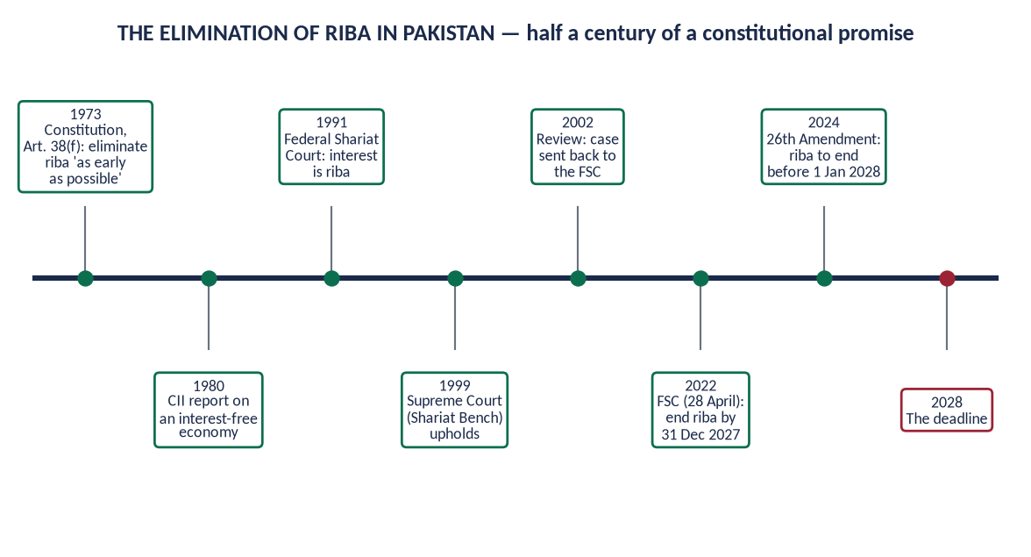
Figure 18 · The elimination of riba in Pakistan.
- Article 38(f) of the 1973 Constitution directs the state to eliminate riba 'as early as possible'.
- The Council of Islamic Ideology reported on an interest-free economy (1980).
- The Federal Shariat Court declared interest to be riba (1991). The Shariat Appellate Bench of the Supreme Court upheld this (1999), but on review (2002) the case was sent back to the FSC.
- On 28 April 2022 the FSC ruled that the interest-based system must be replaced by 31 December 2027.
- The 26th Constitutional Amendment (2024) amended Article 38(f) to require riba to be eliminated as early as possible, and before 1 January 2028.
- The path:
- converting government debt to sukuk;
- expanding Islamic banking;
- Islamic monetary tools for the State Bank;
- training and awareness.
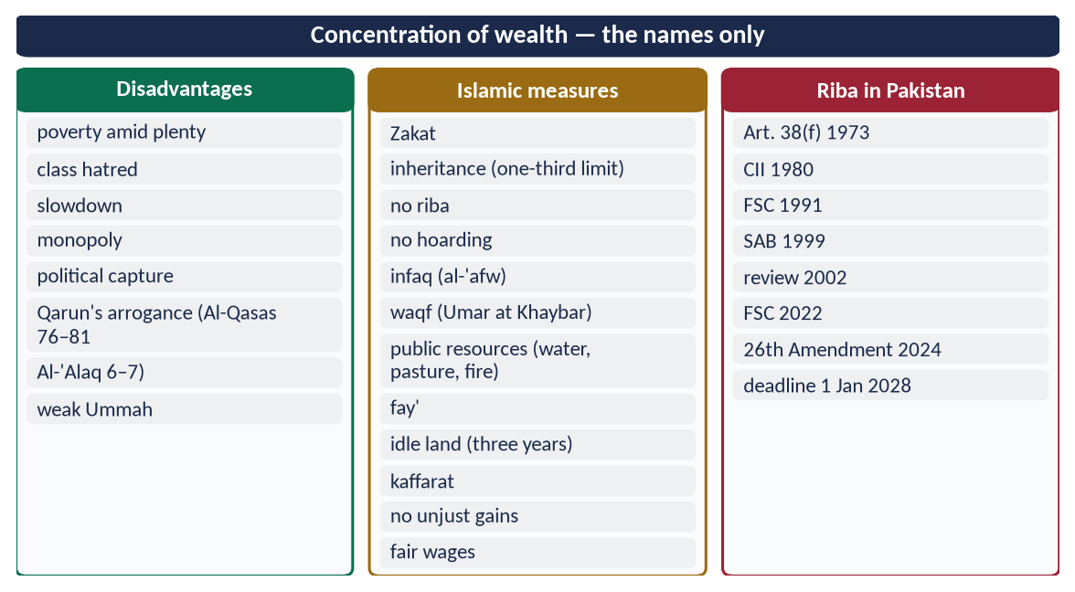
Figure 19 · At a glance — concentration of wealth — the names only. The detail is in the sections above.

Chapter 11 · The Judicial System of Islam
A syllabus line never asked, and so a strong likely question.

11.1 The place of justice in Islam
✦ QURAN
﴿لَقَدۡ أَرۡسَلۡنَا رُسُلَنَا بِٱلۡبَيِّنَٰتِ وَأَنزَلۡنَا مَعَهُمُ ٱلۡكِتَٰبَ وَٱلۡمِيزَانَ لِيَقُومَ ٱلنَّاسُ بِٱلۡقِسۡطِۖ …﴾
“We sent Our messengers with clear proofs and sent down with them the Book and the Balance, so that people may uphold justice.” (Al-Hadid, Quran)
➜ We sent Our messengers with clear proofs and sent down with them the Book and the Balance so that people may uphold justice.

✦ QURAN
﴿إِنَّ ٱللَّهَ يَأۡمُرُكُمۡ أَن تُؤَدُّواْ ٱلۡأَمَٰنَٰتِ إِلَىٰٓ أَهۡلِهَا وَإِذَا حَكَمۡتُم بَيۡنَ ٱلنَّاسِ أَن تَحۡكُمُواْ بِٱلۡعَدۡلِۚ …﴾
“Indeed, Allah commands you to render trusts to those entitled to them, and when you judge between people, to judge with justice.” (An-Nisa, Quran)
➜ 'When you judge between people, judge with justice.'

✦ QURAN
﴿إِنَّآ أَنزَلۡنَآ إِلَيۡكَ ٱلۡكِتَٰبَ بِٱلۡحَقِّ لِتَحۡكُمَ بَيۡنَ ٱلنَّاسِ بِمَآ أَرَىٰكَ ٱللَّهُۚ وَلَا تَكُن لِّلۡخَآئِنِينَ خَصِيمٗا﴾
“Indeed, We have revealed to you, [O Muhammad], the Book in truth so you may judge between the people by that which Allah has shown you. And do not be for the deceitful an advocate.” (An-Nisa, Quran)
➜ We have sent down to you the Book in truth so that you may judge between people by what Allah has shown you. Do not be an advocate for the treacherous.

✦ QURAN
﴿يَٰدَاوُۥدُ إِنَّا جَعَلۡنَٰكَ خَلِيفَةٗ فِي ٱلۡأَرۡضِ فَٱحۡكُم بَيۡنَ ٱلنَّاسِ بِٱلۡحَقِّ وَلَا تَتَّبِعِ ٱلۡهَوَىٰ فَيُضِلَّكَ عَن سَبِيلِ ٱللَّهِۚ …﴾
“O Dawud, We have made you a vicegerent on the earth, so judge between people in truth and do not follow desire, lest it lead you astray from the way of Allah.” (Sad, Quran)
➜ 'O Dawud, We have made you a khalifah on earth, so judge between people in truth and do not follow desire.'

11.2 The salient features of the Islamic judicial system
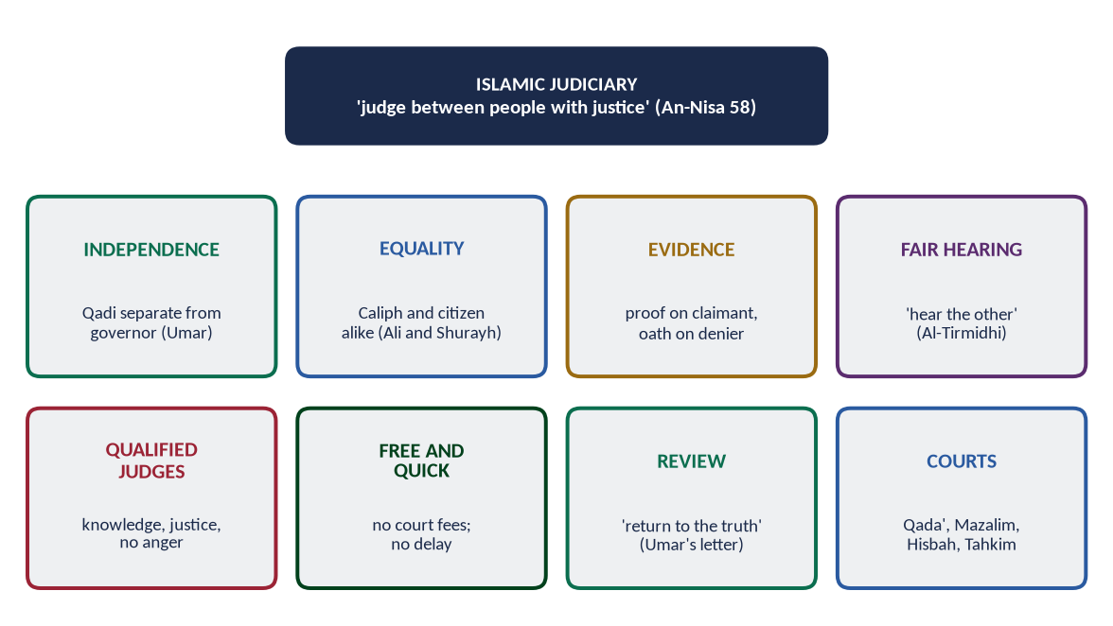
Figure 20 · The salient features of the Islamic judicial system.

(1) Independence of the judiciary
Hazrat Umar (RA) separated judges from governors — Shurayh in Kufa, Abu Musa al-Ash'ari in Basra, Qays ibn Abi al-'As in Egypt — and paid them from the treasury so that they depended on no one.

(2) Equality before the law
✦ HADITH
وَايْمُ اللَّهِ لَوْ أَنَّ فَاطِمَةَ بِنْتَ مُحَمَّدٍ سَرَقَتْ لَقَطَعْتُ يَدَهَا
“By Allah, if Fatimah the daughter of Muhammad stole, I would cut off her hand.” (Al-Bukhari and Muslim)

Ali (RA), as Caliph, lost a case over his armour before Qadi Shurayh; Umar (RA) appeared as a litigant before Zayd ibn Thabit.

(3) Rules of evidence
✦ HADITH
الْبَيِّنَةُ عَلَى الْمُدَّعِي وَالْيَمِينُ عَلَى الْمُدَّعَى عَلَيْهِ
“The burden of proof is on the claimant, and the oath is on the one against whom the claim is made.” (Al-Tirmidhi)

The means of proof:
- witnesses (Al-Baqarah 282; An-Nur 4);
- confession (iqrar);
- oath;
- documents — 'write it down' (Al-Baqarah 282);
- circumstantial evidence (qara'in) in some cases.

(4) Hearing both sides
✦ HADITH
إِذَا تَقَاضَى إِلَيْكَ رَجُلَانِ فَلَا تَقْضِ لِلْأَوَّلِ حَتَّى تَسْمَعَ كَلَامَ الْآخَرِ
“When two men bring a case to you, do not judge for the first until you have heard the other.” (Al-Tirmidhi)
➜ The Prophet's ﷺ instruction to Ali (RA).

(5) Judgement on the apparent evidence
✦ HADITH
إِنَّمَا أَنَا بَشَرٌ، وَإِنَّكُمْ تَخْتَصِمُونَ إِلَيَّ، وَلَعَلَّ بَعْضَكُمْ أَنْ يَكُونَ أَلْحَنَ بِحُجَّتِهِ مِنْ بَعْضٍ ... فَإِنَّمَا أَقْطَعُ لَهُ قِطْعَةً مِنَ النَّارِ
“I am only a human being. You bring your disputes to me, and perhaps one of you is more eloquent in his argument than another … if I give someone what belongs to his brother, I am only giving him a piece of the Fire.” (Al-Bukhari and Muslim)
➜ The judge rules on evidence. A false winner is not freed from sin.

(6) The presumption of innocence
Istishab: a person is innocent until proved guilty. The jurists' maxim: 'Avert the fixed punishments (hudud) where there is doubt' (based on reports in Al-Tirmidhi and others). Umar suspended the penalty of theft in the famine year.

(7) Qualified, upright judges
✦ HADITH
الْقُضَاةُ ثَلَاثَةٌ: وَاحِدٌ فِي الْجَنَّةِ، وَاثْنَانِ فِي النَّارِ
“Judges are three: one in Paradise and two in the Fire.” (Abu Dawud)
➜ The one in Paradise knew the truth and judged by it. One who knew and judged unjustly, and one who judged in ignorance, are in the Fire.

A judge must be Muslim, adult, sane, just and learned in the law (al-Mawardi).

(8) The judge's temperament
✦ HADITH
لَا يَقْضِيَنَّ حَكَمٌ بَيْنَ اثْنَيْنِ وَهُوَ غَضْبَانُ
“No judge should judge between two people while he is angry.” (Al-Bukhari and Muslim)

(9) No bribery, no gifts
✦ QURAN
﴿وَلَا تَأۡكُلُوٓاْ أَمۡوَٰلَكُم بَيۡنَكُم بِٱلۡبَٰطِلِ وَتُدۡلُواْ بِهَآ إِلَى ٱلۡحُكَّامِ لِتَأۡكُلُواْ فَرِيقٗا مِّنۡ أَمۡوَٰلِ ٱلنَّاسِ بِٱلۡإِثۡمِ وَأَنتُمۡ تَعۡلَمُونَ﴾
“And do not consume one another's wealth unjustly or send it [in bribery] to the rulers in order that [they might aid] you [to] consume a portion of the wealth of the people in sin, while you know [it is unlawful].” (Al-Baqarah, Quran)
➜ Do not consume one another's wealth unjustly, nor offer it to the rulers (judges) to consume a portion of others' wealth sinfully.

'The Messenger of Allah ﷺ cursed the briber and the bribe-taker' (Abu Dawud; Al-Tirmidhi).

(10) Free and speedy justice
There were no court fees. Cases were heard openly in the mosque or the court, and decided without delay. Umar's letter set time limits for producing evidence.

(11) Review and appeal
'Do not let a judgement you made yesterday, then reconsidered, stop you from returning to the truth' (Umar's letter to Abu Musa).

(12) Justice to non-Muslims
✦ QURAN
﴿سَمَّـٰعُونَ لِلۡكَذِبِ أَكَّـٰلُونَ لِلسُّحۡتِۚ فَإِن جَآءُوكَ فَٱحۡكُم بَيۡنَهُمۡ أَوۡ أَعۡرِضۡ عَنۡهُمۡۖ وَإِن تُعۡرِضۡ عَنۡهُمۡ فَلَن يَضُرُّوكَ شَيۡـٔٗاۖ وَإِنۡ حَكَمۡتَ فَٱحۡكُم بَيۡنَهُم بِٱلۡقِسۡطِۚ إِنَّ ٱللَّهَ يُحِبُّ ٱلۡمُقۡسِطِينَ﴾
“[They are] avid listeners to falsehood, devourers of [what is] unlawful. So if they come to you, [O Muhammad], judge between them or turn away from them. And if you turn away from them - never will they harm you at all. And if you judge, judge between them with justice. Indeed, Allah loves those who act justly.” (Al-Ma'idah, Quran)
➜ If you judge, judge between them with justice. Indeed, Allah loves the just.

A Jewish man was declared innocent against a Muslim who had framed him (An-Nisa 105–113, revealed about Tu'mah ibn Ubayriq).

11.2a The Prophet ﷺ as judge
- The Makhzumi woman — he refused intercession for a noble thief: 'If Fatimah stole …'.
- Al-Zubayr and his neighbour — in a dispute over watering fields, he ruled by the order of the land, and the verse 'they will not believe until they make you judge' (An-Nisa 65) was revealed.
- Hind's complaint — when Abu Sufyan's wife said he did not give enough for her needs, he allowed her to take 'what is sufficient for you and your child, reasonably' (Al-Bukhari and Muslim). This is the principle of maintenance by custom.
- The disputing heirs — he warned that a clever argument does not make a false claim true ('a piece of the Fire').

11.2b Great judges of Islamic history
- Qadi Shurayh — judge of Kufa for many decades from the time of Umar (RA). He ruled against Caliph Ali (RA) in the armour case.
- Imam Abu Hanifah — refused the office of judge under the Abbasid Caliph al-Mansur, fearing he could not stay independent, and was imprisoned for it.
- Imam Abu Yusuf — the first Qadi al-Qudat; he appointed judges across the empire and wrote Kitab al-Kharaj.

11.3 The courts and institutions
Institution | Function
Qada' | The ordinary court under a Qadi
Qadi al-Qudat | Chief justice. Imam Abu Yusuf (d. 798) was the first to hold the title, under Harun al-Rashid
Diwan al-Mazalim | Complaints against officials and the powerful
Hisbah | Market and public morality (Topic 8)
Tahkim | Arbitration — 'appoint an arbiter from his family and an arbiter from hers' (An-Nisa 35)
Sulh | Reconciliation — 'reconciliation is best' (An-Nisa 128)

11.4 Punishments in brief
- Hudud — fixed penalties for a few crimes. They are proved only by strict evidence, and averted by doubt.
- Qisas and diyah — retaliation or blood-money for injury and killing. The victim's family may forgive (Al-Baqarah 178).
- Ta'zir — discretionary penalties for all other offences, set by the state.

11.5 Lessons for Pakistan
Pakistan's courts have over two million pending cases. Justice is slow and costly, and the poor often turn to jirgas or give up. The Islamic model points to:
- more judges and fixed time limits;
- cheap and free access for the poor;
- ADR — tahkim and sulh under law;
- integrity and independence of judges;
- the Federal Shariat Court keeping laws within the Quran and Sunnah.
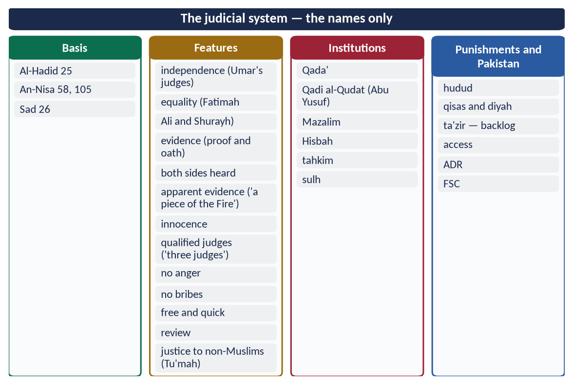
Figure 21 · At a glance — the judicial system — the names only. The detail is in the sections above.

Chapter 12 · The Administrative System of Islam
Taught in detail in Topic 8. Here, its salient features as part of the code of life.

12.1 The salient features
- (1) Office as a trust: An-Nisa 58; 'it is a trust … disgrace and regret' (Muslim).
- (2) Merit: 'the strong and the trustworthy' (Al-Qasas 26); 'a knowing guardian' (Yusuf 55).
- (3) Service and access: 'whoever shuts himself away from their needs' (Abu Dawud); Umar's rule of no doorkeeper.
- (4) Accountability: 'each of you is a shepherd'; Umar's asset register, inspector and Hajj hearings.
- (5) Simplicity: no luxury for officials.
- (6) Honesty: no ghulul, no bribes, no gifts of office (Ibn al-Lutbiyyah).
- (7) Consultation: Ash-Shura 38.
- (8) Decentralisation: provinces with governors, judges, treasurers and police.

12.2 The departments (diwans) of the early state
Department | Function
Diwan al-Jund | Register of soldiers and stipends (Umar)
Diwan al-Kharaj | Land revenue and taxes
Bayt al-Mal | Public treasury
Diwan al-Rasa'il | Correspondence and records
Diwan al-Barid | Postal and intelligence service (organised under the Umayyads)
Shurtah / Ahdath | Police
Qada' | Judiciary
Hisbah | Market and public order

12.3 The Prophet's ﷺ and Umar's model
- The Prophet ﷺ:
- governors (Mu'adh to Yemen, 'Attab to Makkah);
- secretaries (Zayd ibn Thabit);
- Zakat collectors checked on return;
- market inspection.
- Umar (RA):
- provinces;
- the Diwan;
- the Hijri calendar (17 AH);
- prisons;
- canals;
- the census;
- written conditions and checks on governors.

12.4 Lessons for Pakistan's administration
- Merit in recruitment and promotion, not sifarish.
- Access: officers who meet the public, open offices, and the Citizen's Portal.
- Simplicity: fewer perks and less protocol.
- Accountability: asset declarations and inspections, as Umar kept.
- Decentralisation: real power and funds for local governments (Article 140A), as Umar's provinces had.
- Records and technology: the modern Diwan — digital files, e-governance.
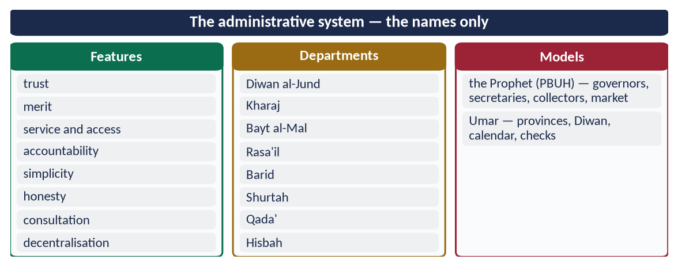
Figure 22 · At a glance — the administrative system — the names only. The detail is in the sections above.

Part Two — Contemporary Challenges, Narratives and Hot Debates

13.1 The elimination of riba by 2028 — can it be done?
Why yes:
- the Constitution (Article 38(f), after the 26th Amendment of 2024) now fixes a deadline;
- the FSC judgement of 2022 was accepted by the government and by several banks, which withdrew their appeals;
- Islamic banking already holds about a quarter of banking assets;
- the government has issued sukuk regularly.
The challenges:
- most government debt, domestic and foreign, is interest-based;
- the IMF and other lenders work in interest;
- trained staff and Shari'ah-compliant monetary tools are still few;
- public trust is limited.
The balanced view: the deadline is a constitutional duty. It requires a phased plan:
- convert domestic debt to sukuk;
- give Islamic tools to the State Bank;
- train bankers;
- deal with foreign debt through Islamic modes over time.

13.2 Islamic banking — the real thing or a new label?
Critics say Islamic banks rely mostly on murabahah and ijarah, benchmarked to interest rates such as KIBOR, and rarely offer true mudarabah or musharakah risk-sharing. Defenders reply:
- the contracts are different in law — real assets, real sale, no penalty-interest;
- benchmarking a price is not riba;
- the move to risk-sharing is gradual.
The Islamic test: do the contracts meet the conditions of a real sale or partnership? And do they serve the Maqasid — justice and circulation?

13.3 Zakat — a system underused
Pakistan's Zakat and Ushr Ordinance (1980) deducts Zakat from certain bank accounts on the first of Ramadan. Many account-holders file exemption declarations, and collections remain small compared with the potential of voluntary Zakat. Reform ideas:
- a transparent, digital Zakat system trusted by the public;
- targeting through the BISP poverty database;
- professional management of Zakat funds;
- strong local committees.

13.4 Ijtihad on new questions
- Artificial intelligence — who is responsible for harm done by a machine? Is AI-generated content honest?
- Digital currencies — scholars differ: some allow regulated coins backed by value; others forbid speculative, unbacked coins because of gharar.
- Climate change — the Maqasid (protecting life) and man as trustee (khalifah) make environmental protection a religious duty.
- Bioethics — gene editing, surrogacy (generally forbidden by the Fiqh Academy because it mixes lineage), end-of-life care.
All require collective Ijtihad: scholars working with experts.

13.5 Taqlid and Ijtihad — a false fight
For the ordinary Muslim, following a qualified school (taqlid) is the Quran's instruction: 'Ask the people of knowledge if you do not know' (An-Nahl 43). For new questions, qualified Ijtihad is a duty. The two are partners. The danger lies in two extremes: rigid taqlid that refuses all new thought, and unqualified 'Ijtihad' by people who lack its conditions.

13.6 Parliament and Ijma in Pakistan
The CII sends its reports to Parliament, but many have not been debated. Reform ideas:
- a time limit for Parliament to discuss the CII's reports;
- joint committees of legislators and scholars on major laws;
- stronger research capacity for the CII.
This would give Iqbal's idea of a Muslim legislative assembly guided by scholars practical form.
DEBATE · IS ISLAMIC ECONOMICS A 'THIRD WAY' OR JUST ETHICS?
Some say Islamic economics is only a set of moral rules attached to capitalism. The reply: it has distinct institutions that change the structure of an economy:
• a ban on interest;
• a compulsory wealth levy (Zakat);
• a distributive inheritance law;
• a ban on hoarding and gharar;
• public ownership of essentials;
• a welfare state.
Its ethics and its institutions work together. That is why it is called a system.

Part Three — The Examiner's Record and Five Likely Questions

14.1 Every question on this topic, 2015–2026
Year | Question | Ch.
2015 Q6 | Write a comprehensive note on the importance of Sunnah in interpretation and legislation. | 3
2017 Q8 | Define Ijma' (consensus) and explain its different kinds. Highlight its importance in the light of the Qur'ān and Sunnah. | 4
2018 Q2 | Define Ijtihad, also highlight its contemporary importance in the light of Islamic Fiqh. | 6
2020 Q8 | "Islamic Financial and Economic system is the solution of the human financial problems". Discuss. | 9
2022 Q3 | Write down the main principles of Islamic Economics. How do these principles provide solutions to contemporary challenges? | 9
2022 Q4 | Elaborate the concept and importance of Ijtihad and explain its principles. | 6
2023 Q5 | Define Ijma (consensus) and explain its different kinds. Can legislation by a parliament of an Islamic state be regarded as a valid consensus? | 4
2025 Q5 | What are the disadvantages of concentration of wealth? What economic measures has Islam introduced to prevent this concentration of wealth? | 10

All eight are answered in T9QA. Related: Zakat and the economy (2015, 2017, 2018) — Topic 2; Pakistani society (2022 Q7) — Topic 6.

14.2 What the record teaches
- The sources five times:
- the Sunnah (2015);
- Ijma (2017, 2023) — the same definition, with a new twist in 2023 (parliament);
- Ijtihad (2018, 2022).
- Economics three times (2020, 2022, 2025), always asking for solutions.
- Never asked: the social, judicial and administrative systems; Qiyas; the Maqasid.

14.3 Five likely questions
1. Discuss the salient features of the judicial system of Islam.
2. Explain the social system of Islam and its relevance to modern society.
3. What is Qiyas? Explain its pillars, conditions and importance as a source of Islamic law.
4. Explain the Maqasid al-Shari'ah and their use in modern legislation.
5. Riba is the root of economic injustice. Discuss, with reference to the elimination of riba in Pakistan.

Part Four — The One-Liner Bank

One-liners · The code of life and the Maqasid
1. 'Indeed, the Din with Allah is Islam' — Aal-e-Imran 19.
2. 'Enter into Islam completely' — Al-Baqarah 208.
3. 'This day I have perfected your religion' — Al-Ma'idah 3, at the Farewell Pilgrimage.
4. The Quran is 'a clarification of all things' — An-Nahl 89.
5. 'I was sent to perfect good character' — Al-Muwatta', Ahmad.
6. 'The change of rulings with the change of times cannot be denied' — Majallah, Article 39.
7. The five essentials of the Maqasid were listed by al-Ghazali in Al-Mustasfa.
8. The five: faith, life, intellect, lineage, wealth.
9. The three levels of the Maqasid are set out by al-Shatibi in Al-Muwafaqat.
10. The three levels: daruriyyat, hajiyyat, tahsiniyyat.
11. A modern scholar of the Maqasid: Ibn Ashur (Tunisia).
12. Shari'ah literally means 'the path to water'.
13. Fiqh literally means 'understanding'.

One-liners · The sources and the Quran
14. The four primary sources: Quran, Sunnah, Ijma, Qiyas.
15. The hadith that fixes the order of sources: Mu'adh ibn Jabal sent to Yemen.
16. Al-Shafi'i drew all four sources from An-Nisa 59.
17. The Quran has 114 surahs and about 6,236 verses.
18. Legal verses of the Quran (ayat al-ahkam): about 500.
19. The Quran is qat'i al-thubut — certain in transmission.
20. Wine was forbidden in four stages; the final verse is Al-Ma'idah 90.
21. 'Three quru'' (Al-Baqarah 228) is an example of a zanni (probable) meaning.

One-liners · The Sunnah
22. Sunnah: qawl, fi'l, taqrir — sayings, actions, approvals.
23. 'Whatever the Messenger gives you, take it' — Al-Hashr 7.
24. 'Whoever obeys the Messenger has obeyed Allah' — An-Nisa 80.
25. 'It is nothing but revelation revealed' — An-Najm 3–4.
26. The Prophet ﷺ was sent 'to make clear to people' — An-Nahl 44.
27. 'I have been given the Quran and something like it' — Abu Dawud.
28. 'I have left among you two things: the Book of Allah and my Sunnah' — Al-Muwatta'.
29. 'Pray as you have seen me praying' — Al-Bukhari.
30. 'Take your rites from me' — Muslim (Hajj).
31. 'The killer does not inherit' — the Sunnah specifies the general.
32. Zulm in Al-An'am 82 was explained as shirk (Luqman 13).
33. The 'middle prayer' (Al-Baqarah 238) is 'Asr.
34. Marrying a woman with her aunt is forbidden by the Sunnah.
35. The grandmother's share of one-sixth comes from the Sunnah.
36. Official collection of hadith was ordered by Umar ibn Abd al-Aziz (about 100 AH).
37. The scholar who led that collection: Ibn Shihab al-Zuhri.
38. 'Abdullah ibn 'Amr's written collection: Al-Sahifah al-Sadiqah.
39. Laws must conform to the 'Quran and Sunnah' — Article 227.

One-liners · Ijma
40. Ijma literally means firm resolve and agreement.
41. Ijma: agreement of all the mujtahids of the Ummah, after the Prophet ﷺ, on a shar'i ruling.
42. Al-Shafi'i's proof of Ijma: 'the way of the believers' — An-Nisa 115.
43. 'My Ummah will not agree upon misguidance' — Ibn Majah.
44. 'The hand of Allah is with the jama'ah' — Al-Tirmidhi.
45. Ijma where the rest stay silent: Ijma sukuti (accepted by the Hanafis).
46. Imam Malik gave authority to the practice of the people of Madinah.
47. The first great Ijma: the Caliphate of Abu Bakr (RA).
48. The book recording points of consensus: Kitab al-Ijma' by Ibn al-Mundhir.
49. The OIC's International Islamic Fiqh Academy was created in 1981 (Jeddah).
50. Iqbal: a Muslim legislative assembly is 'the only possible form Ijma can take in modern times'.
51. The 22 principles of an Islamic state were agreed by 31 ulema of all schools in 1951.
52. Council of Islamic Ideology: Articles 228–231.

One-liners · Qiyas and the secondary sources
53. Qiyas literally means measuring.
54. The four pillars of Qiyas: asl, far', hukm, 'illah.
55. The 'illah of the prohibition of wine: intoxication (iskar).
56. 'Every intoxicant is khamr, and every intoxicant is forbidden' — Muslim.
57. 'So take warning (fa'tabiru), O people of insight' — Al-Hashr 2.
58. Those who can draw conclusions (yastanbitunahu) — An-Nisa 83.
59. The Prophet ﷺ compared Hajj for a dead mother to paying her debt.
60. Juristic preference (Hanafi): istihsan.
61. The classical example of istihsan: the istisna' contract.
62. Public interest not addressed by a text: maslahah mursalah (Maliki).
63. 'Custom is authoritative': al-'adah muhakkamah.
64. Presumption of continuity: istishab — innocent until proved guilty.
65. Blocking the means: sadd al-dhara'i' — Al-An'am 108.

One-liners · Ijtihad
66. Ijtihad comes from juhd — effort.
67. Iqbal called Ijtihad 'the principle of movement in the structure of Islam'.
68. A judge who strives and errs gets one reward; if right, two — Al-Bukhari and Muslim.
69. 'A party should go forth to gain understanding in religion' — At-Tawbah 122.
70. At Banu Qurayzah, the Prophet ﷺ approved both readings of his command.
71. 'Amr ibn al-'As made tayammum on a freezing night, citing An-Nisa 29.
72. Umar stopped the share of 'those whose hearts are reconciled' when its cause ended.
73. Al-Shatibi made understanding the Maqasid the first condition of a mujtahid.
74. The founders of the four schools are mujtahid mutlaq.
75. Abu Yusuf and Muhammad al-Shaybani were mujtahids within the school.
76. 'No Ijtihad where there is a text' — la ijtihad ma'a al-nass.
77. 'Hardship brings ease' — al-mashaqqah tajlib al-taysir.
78. 'Certainty is not removed by doubt.'
79. The Fiqh Academy approved cooperative insurance (takaful) in 1985.
80. The Fiqh Academy allowed organ transplantation, with conditions, in 1988.
81. The Fiqh Academy forbade human cloning in 1997.
82. Reformer of the 18th century who called for Ijtihad: Shah Waliullah (d. 1762).

One-liners · The social, political, judicial and administrative systems
83. 'The most noble of you with Allah is the most righteous' — Al-Hujurat 13.
84. 'We have honoured the children of Adam' — Al-Isra 70.
85. Marriage brings 'tranquillity, affection and mercy' — Ar-Rum 21.
86. 'Jibril kept urging me about the neighbour' — Al-Bukhari and Muslim.
87. The political system's charter in Pakistan: Article 2A (Objectives Resolution).
88. 'The burden of proof is on the claimant, the oath on the one who denies' — Al-Tirmidhi.
89. 'I am only a human … I give him a piece of the Fire' — on judging by evidence.
90. 'No judge should judge while angry' — Al-Bukhari and Muslim.
91. 'Judges are three: one in Paradise, two in the Fire' — Abu Dawud.
92. The first Qadi al-Qudat (chief justice): Imam Abu Yusuf.
93. The court of complaints against officials: Diwan al-Mazalim.
94. Arbitration between spouses: An-Nisa 35.
95. An-Nisa 105–113 cleared a Jewish man framed by Tu'mah ibn Ubayriq.
96. The postal and intelligence department: Diwan al-Barid.

One-liners · The economic system and wealth
97. 'Spend of that in which He has made you trustees' — Al-Hadid 7.
98. 'Allah has permitted trade and forbidden riba' — Al-Baqarah 275.
99. 'Be informed of a war from Allah and His Messenger' — Al-Baqarah 279.
100. Cursed: the one who consumes riba, pays it, writes it and witnesses it — Muslim.
101. 'None hoards except a sinner' — Muslim.
102. The Prophet ﷺ forbade the sale of gharar — Muslim.
103. The truthful, trustworthy merchant is with the prophets — Al-Tirmidhi.
104. 'Give the worker his wage before his sweat dries' — Ibn Majah.
105. 'Neither extravagant nor miserly' — Al-Furqan 67.
106. 'So that wealth does not circulate only among the rich' — Al-Hashr 7.
107. Al-Hashr 7 was revealed about the fay' of Banu Nadir.
108. 'Taken from their rich and returned to their poor' — to Mu'adh.
109. Bequests are limited to one-third: 'a third, and a third is a lot'.
110. The origin of waqf: Umar's land at Khaybar.
111. 'Muslims are partners in three: water, pasture and fire' — Abu Dawud.
112. Idle land is lost after three years — Umar (Kitab al-Kharaj).
113. The Quran's story of wealth and arrogance: Qarun (Al-Qasas 76–82).
114. Pakistan's first sovereign sukuk: 2008.
115. Interest-free microfinance in Pakistan: Akhuwat (2001).
116. Pakistan's Zakat and Ushr Ordinance: 1980.
117. FSC declared interest to be riba: 1991; SC Shariat Bench upheld: 1999.
118. FSC's riba judgement: 28 April 2022, deadline 31 December 2027.
119. The 26th Amendment (2024): riba to end before 1 January 2028.
ONE-LINER COUNT
This topic carries 119 one-liners, numbered 1–119. Revise them in blocks of twenty; tick the ones you can answer without looking.

Part Five — Revision Notes · Topic 9
Read these on the night before the paper. Every chapter is broken into its sections, each giving the chain of ideas, the evidence to quote, and the names, dates and numbers. The last line of each chapter tells you which question it serves.

R9.0 The whole topic in one picture
- Code of life: Din → complete (Al-Ma'idah 3) → features → Maqasid (five essentials, three levels).
- Sources: Quran → Sunnah → Ijma → Qiyas (Mu'adh; An-Nisa 59) → secondary sources → Ijtihad is the engine behind the last three.
- Systems: social (equality, family) · political (sovereignty, shura) · economic (no riba, Zakat, circulation) · judicial (independent, equal) · administrative (trust, merit).
- Pakistan: Article 227 · CII · FSC · riba by 2028.

R9.1 Chapter 1 · The code of life
- Din: Aal-e-Imran 19 · Al-Baqarah 208 · Al-Ma'idah 3 (10 AH) · An-Nahl 89.
- Eleven features: divine (Al-Mulk 14) · comprehensive · balanced (Al-Qasas 77) · just (An-Nahl 90) · easy (Al-Baqarah 185; Al-Hajj 78) · universal (Al-Anbiya 107) · permanent and flexible (Majallah Art. 39) · moral ('perfect good character') · rights with duties · welfare · practical.
- Maqasid (draw the circle):
- the five essentials — faith, life, intellect, lineage, wealth (al-Ghazali, Al-Mustasfa);
- the table: protected by … / violated by …;
- the three levels (al-Shatibi);
- Ibn Ashur;
- use: the test of every law and Ijtihad.
- Exam use: background for every T9 answer; likely question on the Maqasid.

R9.2 Chapter 2 · The sources and the Quran
- Order: Mu'adh (Book → Sunnah → my judgement) · An-Nisa 59 (al-Shafi'i: four sources).
- Quran: definition (word of Allah, Arabic, Jibril, tawatur, mushaf, worship) · 114 / 6,236 · ~500 legal verses · table of areas.
- Method: principles · few obligations (Al-Ma'idah 101) · ease · gradual (wine: An-Nahl 67 → Al-Baqarah 219 → An-Nisa 43 → Al-Ma'idah 90) · reasons given · qat'i vs zanni (quru').

R9.3 Chapter 3 · The Sunnah (2015)
- Meaning: qawl · fi'l · taqrir.
- Authority from the Quran: Al-Hashr 7 · An-Nisa 80 · An-Najm 3–4 · An-Nahl 44 · An-Nisa 65 · Al-Ahzab 21.
- Authority from the Sunnah: 'the Quran and its like' (Abu Dawud) · 'two things' (Al-Muwatta').
- Interpretation (draw the five roles):
- explains — prayer ('pray as you see me'), Zakat, Hajj ('take your rites');
- specifies — the killer does not inherit;
- restricts — the wrist, the nisab;
- explains words — zulm = shirk; the middle prayer = 'Asr;
- confirms.
- Legislation: aunt and niece · gold and silk · grandmother 1/6 · donkeys' meat · Zakat al-Fitr · gharar.
- Living model: justice in practice · Umar: 'take them with the Sunnah' (Al-Darimi).
- Preservation: Sahifah Sadiqah · Umar ibn Abd al-Aziz / al-Zuhri · isnad and rijal · Muwatta' · Sihah Sittah.
- Pakistan: Article 227 · FSC.
- Denial of hadith: four replies.
- Exam use: 2015 → meaning → authority → interpretation (five roles with examples) → legislation → preservation → Pakistan.

R9.4 Chapter 4 · Ijma (2017, 2023)
- Definition: literal (resolve — Yunus 71; agreement) → technical → six elements (mujtahids · all · Ummah · after the Prophet ﷺ · shar'i ruling · sanad).
- Evidence:
- An-Nisa 115 (al-Shafi'i);
- Al-Baqarah 143;
- Aal-e-Imran 110, 103;
- 'will not agree on misguidance' (Ibn Majah);
- 'hand of Allah with the jama'ah' (Al-Tirmidhi);
- the hand-span.
- Kinds (draw the three rows):
- explicit / tacit (Hanafi);
- Companions / later ages / Madinah (Malik);
- qat'i / zanni.
- Examples: Abu Bakr · the Quran compiled · grandmother 1/6 · Zakat-refusers · grandmother in marriage · five prayers.
- Importance: unity · fixed meaning · protection · bridge · collective law · new questions.
- Procedure:
- classical — consulting the Companions, travel, letters, Ibn al-Mundhir;
- modern — the Fiqh Academy (1981), the MWL Fiqh Council, the CII, the FSC.
- Parliament (2023):
- for — Iqbal's assembly; consent; Shura; experts;
- against — not mujtahids; majority; one country; changeable; may oppose texts;
- verdict — not classical Ijma, but a valid collective Ijtihad if within Article 227, with the CII, reviewable by the FSC, and by broad agreement;
- examples — 1949, 31 ulema 1951, 1973.
- Exam use: 2017 → definition, evidence, kinds, examples, importance. 2023 → definition and kinds briefly → the parliament debate → verdict with conditions.

R9.5 Chapter 5 · Qiyas and the secondary sources
- Qiyas:
- definition;
- four pillars (draw them) — wine → drugs, 'illah: intoxication;
- evidence: Al-Hashr 2 · An-Nisa 83 · Mu'adh · the mother's debt (Al-Bukhari) · Umar's letter · Abu Bakr and the prayer;
- conditions of the 'illah: apparent · constant · relevant · extendable · not against a text;
- examples: killer → bequest; the Friday call; the six riba items.
- Secondary sources:
- istihsan (istisna'; Abu Hanifah);
- maslahah mursalah (Quran compiled; Diwan; traffic laws);
- 'urf;
- istishab (innocence; missing person);
- sadd al-dhara'i' (Al-An'am 108);
- qawl al-Sahabi;
- shar' man qablana (qisas).
- Exam use: likely question on Qiyas; supports Ijtihad answers.

R9.6 Chapter 6 · Ijtihad (2018, 2022)
- Concept: juhd; effort in hard things · technical definition · Iqbal: 'principle of movement'.
- Authority:
- An-Nisa 83 · At-Tawbah 122 · Al-Hashr 2;
- two rewards / one reward (Al-Bukhari and Muslim);
- Mu'adh;
- Banu Qurayzah (both approved);
- 'Amr's tayammum.
- The Caliphs' Ijtihad:
- Abu Bakr — Quran, Zakat;
- Umar — Iraq lands, theft in famine, mu'allafat al-qulub, Diwan;
- Uthman — standard copy, second Friday call;
- Ali — six months.
- Conditions (table): Arabic · Quran (500 verses; nasikh–mansukh) · Sunnah · Ijma · usul · Maqasid (Shatibi) · people and times · justice.
- Kinds:
- levels (draw the ladder);
- individual / collective;
- bayani / qiyasi / istislahi;
- partial.
- Ten principles (2022): no Ijtihad with a text · order of sources · Maqasid · ease · no harm · necessity limited · custom and time (Majallah 39) · consequences · certainty · humility (al-Shafi'i).
- The 'closed gate': 4th century AH → taqlid → never fully closed → Shah Waliullah, Iqbal → collective Ijtihad.
- Contemporary importance (table): bioethics (1988 transplants; 1997 cloning) · finance (takaful 1985; sukuk) · technology (AI) · worship (polar times; moon) · environment · state · Pakistan (CII, FSC, riba) · unity.
- Exam use: 2018 → definition → authority → conditions → contemporary importance (the table) → conclusion. 2022 → concept → importance → principles (the ten).

R9.7 Chapter 7 · The social system (likely)
- Foundations: one soul (An-Nisa 1) · equality (Al-Hujurat 13) · dignity (Al-Isra 70) · the Farewell Sermon · brotherhood (Al-Hujurat 10) · Mu'akhat.
- Features: family (Ar-Rum 21) · relatives and neighbours (An-Nisa 36; Jibril) · women · welfare ('one body') · enjoining good (Aal-e-Imran 110) · modesty (An-Nur 30) · ban on evils · knowledge · tolerance · etiquette (the guest).
- Relevance (table): family breakdown · racism · individualism · addiction · exploitation · poverty.

R9.8 Chapter 8 · The political system
- Twelve features: sovereignty · khilafah · the Prophet's ﷺ model · shura · bay'ah and merit · rule of law · justice · accountability · rights · non-Muslims · welfare · conditional obedience.
- Pakistan: Article 2A · more in Topic 8.

R9.9 Chapter 9 · The economic system (2020, 2022)
- Nature: falah · the comparison table (capitalism / socialism / Islam).
- Fourteen principles (draw the wheel):
- trusteeship (Al-Hadid 7; An-Nur 33);
- property with limits (An-Nisa 29);
- halal earning (Al-Baqarah 168; 'the work of his hands');
- no riba (Al-Baqarah 275, 278–279; 'cursed … all equal');
- no maysir or gharar (Al-Ma'idah 90);
- no hoarding (At-Tawbah 34; 'a sinner');
- Zakat (At-Tawbah 60; 2.5% / 5–10% / 20%);
- circulation (Al-Hashr 7);
- fair trade (Al-Mutaffifin 1–3; 'with the prophets');
- moderation (Al-Furqan 67; Al-Isra 27);
- labour ('before the sweat dries');
- inheritance (An-Nisa 7);
- social security;
- contracts (Al-Ma'idah 1).
- Instruments: mudarabah · musharakah · murabahah · ijarah · salam · istisna' · sukuk (2008) · takaful · qard hasan (Akhuwat 2001) · waqf.
- Solutions (table): poverty · inequality · debt · crises (2008; the Vatican newspaper, 2009) · inflation · unemployment · corruption · exploitation · consumerism · environment.
- 'The solution'?
- yes in principle;
- evidence — Umar ibn Abd al-Aziz; 4 trillion dollars; a quarter of Pakistan's banking;
- conditions — real risk-sharing, honest Zakat, governance.
- Exam use: 2020 → thesis → the failures of the present system → Islamic principles as remedies → evidence → conditions. 2022 → principles (numbered, with verses) → the solutions table.

R9.10 Chapter 10 · Concentration of wealth and riba (2025)
- Data: World Inequality Report 2022 (top 10% about three-quarters; bottom half about 2%) · UNDP Pakistan 2020 (elite privilege $17.4 billion, about 6% of GDP).
- Seven disadvantages: poverty amid plenty · class hatred · slowdown · monopoly · political capture · Qarun (Al-Qasas 76–81; Al-'Alaq 6–7) · weak Ummah.
- Twelve measures (draw the flow):
- Zakat ('from their rich to their poor');
- inheritance (one-third limit; no primogeniture);
- no riba;
- no hoarding (At-Tawbah 34–35);
- infaq (al-'afw, Al-Baqarah 219; 'a right', Adh-Dhariyat 19);
- waqf (Umar at Khaybar);
- public resources (water, pasture, fire);
- fay' (Banu Nadir → Al-Hashr 7);
- idle land (three years);
- kaffarat and Zakat al-Fitr;
- no unjust gains;
- fair wages.
- Riba in Pakistan (draw the timeline): 38(f) 1973 · CII 1980 · FSC 1991 · SAB 1999 · review 2002 · FSC 28 April 2022 · 26th Amendment 2024 · deadline 1 January 2028.
- Exam use: 2025 → data → disadvantages (with Qarun) → twelve measures with evidence → Pakistan → conclusion with Al-Hashr 7.

R9.11 Chapter 11 · The judicial system (likely)
- Basis: Al-Hadid 25 · An-Nisa 58, 105 · Sad 26.
- Twelve features (draw the grid):
- independence (Umar's judges);
- equality (Fatimah; Ali before Shurayh; Umar before Zayd);
- evidence ('proof on the claimant'; witnesses, confession, oath, documents);
- both sides heard;
- apparent evidence ('a piece of the Fire');
- innocence (avert hudud by doubt);
- qualified judges ('three judges');
- no anger;
- no bribes (Al-Baqarah 188);
- free and quick;
- review (Umar's letter);
- justice to non-Muslims (Al-Ma'idah 42; Tu'mah).
- Institutions: Qada' · Qadi al-Qudat (Abu Yusuf) · Mazalim · Hisbah · tahkim (An-Nisa 35) · sulh (An-Nisa 128).
- Punishments: hudud · qisas / diyah · ta'zir.
- Pakistan: over 2 million pending cases → judges, time limits, access, ADR, integrity, FSC.

R9.12 Chapter 12 · The administrative system
- Features: trust · merit · access (no doorkeeper) · accountability · simplicity · honesty · consultation · decentralisation.
- Departments: Jund · Kharaj · Bayt al-Mal · Rasa'il · Barid · Shurtah · Qada' · Hisbah.
- Models: the Prophet ﷺ and Umar → more in Topic 8.

R9.13 Part Two · Today
- Riba by 2028: yes (Constitution, FSC, sukuk, a quarter of banking) vs challenges (government debt, IMF, staff) → phased plan.
- Islamic banking: critics (murabahah, KIBOR) vs defenders (real sale) → test by contract and Maqasid.
- Zakat 1980: exemption declarations → digital, BISP targeting, local committees.
- New Ijtihad: AI · crypto (gharar) · climate · bioethics (surrogacy).
- Taqlid and Ijtihad: An-Nahl 43 · partners · two extremes.
- Parliament and the CII: debate reports; joint committees.
- Debate: Islamic economics = ethics + institutions = a system.

R9.14 The figures to draw in the paper
- The pyramid of sources with the secondary sources beneath.
- The Maqasid circle: five essentials, three levels.
- The five roles of the Sunnah.
- The four pillars of Qiyas (wine → drugs).
- The ladder of mujtahids.
- The wheel of economic principles.
- The flow of wealth from the rich to society.
- The riba timeline (1973 → 2028).
- The grid of judicial features.

